The Ultimate Cisco Review

*By: Joe O’Neill*

## ***Foreword (Must Read)***

This review is made for CyberPatriot. Cisco and Networking is a huge, neverending topic, and you could study everything for a month straight and never know it all. I try to include as much knowledge that you will have to know to an extent, but it’s ultimately up to **YOU** to make sure that you’re prepared for Cyber Patriot rounds.

I also created this review specifically for me. While this may help you immensely, I **HIGHLY** suggest that you make your own review. Look at my review, absorb it, and get it ingrained into your mind. Hell, read if over every night before bed and you’ll be a Cisco Genius! Once you understand the material, make your own review. It’s most definitely the best way to show your superiority in Cisco. Don’t be intimidated, and let's get routing!

# Getting Started

1. Enter device, get to CLI, turn on the device with *enable,* enter config mode with *config t* (short for configuration terminal)
2. You may need to assign/type in a password, check your instructions for an enable password. If there is none, try pressing enter. If it doesn’t work, God help you.
3. From here we can view and save the configuration settings with commands. Here is a brief list of commands and what they do:

*show run -*shows the running configuration. (\***Use during Comp*)**

*copy run start-* Copies the running configuration as the configuration that will be applied when the router/switch restarts.

*write memory-*Writes the current configuration into memory

**\*If you are in config mode: Router(config)# You NEED to have *do* in front of your configuration settings commands Ex: do show run\***

1. **Whenever you finish working with a switch or a router, use *copy run start* or *write memory* so if something goes wrong, your settings are saved.**

# Configuration Fundamentals +Security

**Change the name/hostname:**

Router(config)# hostname [hostname you want to change to]

**Change the secret/enable secret/privileged exec password:**

Router(config)# enable secret [password]

**Configure console password:**

Router(config)#line con 0

Router(config-line)#password [password]

Router(config-line)#login

Router(config-line)#exit

**Configure VTY lines/Change telnet password:**

Router(config)# line vty 0 4

Router(config-line)#password [password]

Router(config-line)#login

Router(config-line)#transport input telnet

Router(config-line)#exit

**Configure SSH with local login:**

Router(config)#ip domain-name [domain name they give you (if they haven’t given you one, type *cisco.com* here and you should be fine)]

Router(config)#crypto key generate rsa

How many bits in the modulus [512]: [length of the key (type **1024** as that is the default for ssh) (hitting enter here will give you a length of 512)]

Router(config)#username [name of user] password [password]

Router(config)#line vty 0 4

Router(config-line)#transport input ssh

Router(config-line)#login local

**If you need to enable encryption (service) for a password, type:**

*service password-encryption*

**If you need to configure a banner, type:**

*banner* [*login*/*motd*] *\**[message]*\**

**OTHER CONSOLE LINE Configurations:**

Console messages should not interrupt command entry: ***logging synchronous***

Console inactivity timeout: ***exec timeout #***

# Port Security

Minimum password length command: ***security password min #***

Port Security can be implemented on interfaces to make them secure. To turn on port security, go to the interface, ensure it’s in access mode, and type:

***sw port-security***

Port security can be customized based upon what the instructions tell you:

***sw port-security mac-address sticky***  *logs the MAC Address

*s****w port-security maximum #***[maximum number of MAC Addresses]

***sw port-security violation***[*shutdown/restrict/protect*]

# Assign an IP address:

Router(config)#interface [name of interface]

Router(config-if)#ip address [ip address] [subnet mask]

**IF YOU ARE ON A LAYER 3 SWITCH, MAKE SURE YOU DO/HAVE THESE COMMANDS**

***IP ROUTING***- on config

***NO SWITCHPORT****- on interface to do addressing*

**Subnet mask Chart for Addresses:**

**Net Bits Subnet Mask Total Addresses**

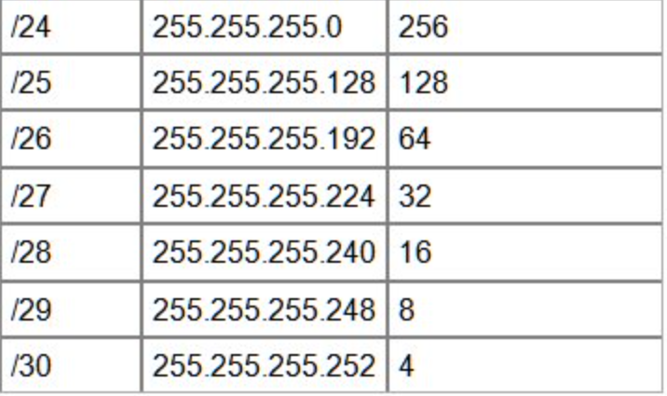

**/31 255.255.255.254 2**

**/32 255.255.255.255 1**

*Steps for Inter vlan trunk config (commands all below):*

1. *Create and name vlans*
2. *Create Management interface (trunk interface that is usually the native/vlan 99) and sub interfaces. Don’t forget to add an ip address, turn the interface on, and add a default gateway*
3. *Configure access ports*
4. *Configure trunk ports*

# Creating VLANs (on a switch)

Switch(config)#vlan [vlan id] -creates the vlan, how you name a vlan

Switch(config-vlan)#exit

Switch(config)#interface vlan [vlan id] -sets vlan to a device, how you assign ip addresses

Switch(config-if)#exit

**WHEN MAKING VLANS, MAKE SURE YOU KNOW WHETHER TO MAKE IT A *TRUNK* PORT OR AN *ACCESS* PORT. AN ACCESS PORT IS CONNECTED TO A SINGLE DEVICE, SUCH AS A PC OR A SERVER. A TRUNK PORT IS CONNECTED TO A NETWORKING DEVICE, SUCH AS A ROUTER OR ANOTHER SWITCH.**

**Making an interface an access port:**

Switch(config)#***interface*** {range-use if multiple ports} [name of interface(s) you want to make an access port]

Switch(config-if)#***switchport mode access***

Switch(config-if)#***switchport access vlan [vlan id]***

Switch(config-if)#***exit***

**Making an interface a trunk port:**

Switch(config)#interface [name of interface you want to make a trunk port]

Switch(config-if)#switchport mode trunk

Switch(config-if)#switchport trunk allowed vlan [vlan #], [vlan #]

(do switchport trunk allowed vlan **add**; if you need to add another vlan to an already made list)

**IF YOU GET THIS**: Command rejected: An interface whose trunk encapsulation is "Auto" can not be configured to "trunk" mode.

**DO THIS COMMAND**: Switch(config-if)#switchport trunk encap dot1q

A trunk sometimes has a Native VLAN, which is a vlan that a packet is put on if it isn’t assigned a particular VLAN. To configure a native VLAN type in:

***sw trunk native vlan***[VLAN #]

**TROUBLESHOOT WITH: *DO show interfaces trunk***

# Switching

### **STP (Spanning Tree Protocol):**

* Prevents loops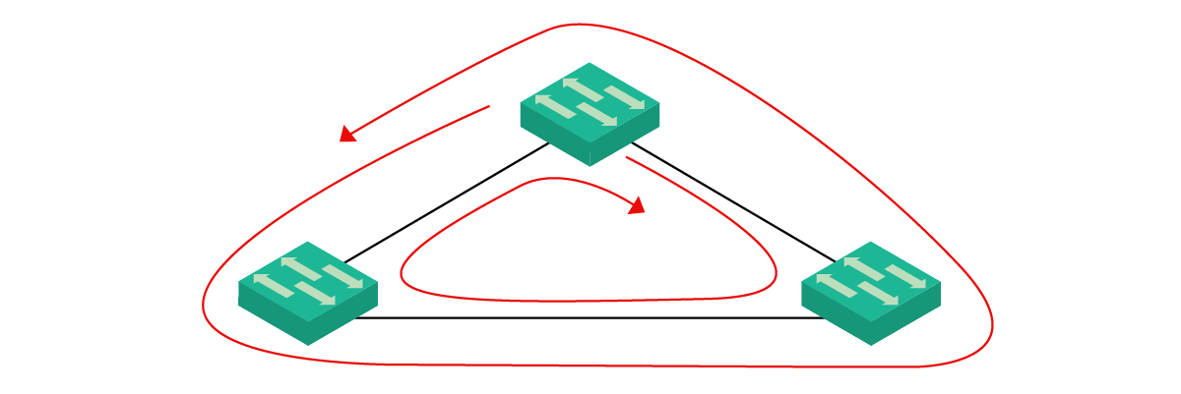
* Extra Switches for Redundancy
* Root port, designated port, blocked port
* [Understanding Spanning Tree Protocol (STP)](https://www.ictshore.com/free-ccna-course/stp-understanding-spanning-tree/)
* spanning-tree mode rapid-pvst (rapid is better, only use if asked tho)
* spanning-tree vlan # root primary/secondary (identify your root bridge, secondary for if primary fails)
* spanning-tree vlan 1 priority 4096 (setting priority, # in increments of 4096)
* (port priority if you want like gig over Fa)
  + interface *FastEthernet0/24*
  + spanning-tree vlan # port-priority 240 (priority increments of 16, lowest is most preferred)

### PortFast and BPDUGuard (used for edge/access/end ports)

* + interface *FastEthernet0/23*
  + spanning-tree portfast (enables end ports as soon as an intermediary device connects to them)
  + spanning-tree bpduguard enable (shuts down port if a BPDU (switch info) is received)
  + spanning-tree portfast default (use as one command on switch to enable all access ports to portfast)
  + spanning-tree portfast bpduguard default
  + (Default commands enable on all non trunk ports)
* [Configure and Troubleshoot Cisco Spanning Tree (STP)](https://www.ictshore.com/free-ccna-course/stp-configuring-spanning-tree/)
* Troubleshooting:
  + show spanning-tree vlan # (output for a vlan)
  + show spanning-tree summary (overview of spanning tree)

**Intervlan Routing:**

***\*****If a trunk port on a switch is connected to a* ***router****, you will need to make sub interfaces on the router for each vlan. Each of the sub-interfaces ARE ON DIFFERENT NETWORKS. IT AS IF THEY ARE TWO SEPARATE CABLES PHYSICALLY. THIS MEANS THAT EACH SUBINTERFACE HAS A DIFFERENT IP ADDRESS RANGE. Do the following on the router for each vlan:****\****

Router(config)#interface [name of interface].1 (Example: Router(config)# interface gig0/0.1, use a different subinterface for each vlan, ie. use gig0/0.1 for VLAN 10, gig0/0.2 for VLAN 20, they might tell you which subinterfaces to use otherwise.)

Router(config-subif)#encapsulation dot1Q [vlan id for that subinterface]

Router(config-subif)#ip address [ip address for that subinterface] [subnet mask]

**Intervlan Routing Explained in Depth:**

So, you have a trunk leading to router and now you need to program the router. This is going to happen by splitting up the interface into pieces, each piece with a different IP address so it can process the different networks on the same port. Type:

*interface* [interface name]*#/#.*[VLAN #]

For example, if we wanted to configure vlan 10 on interface FastEthernet0/0, you would type:

*interface fastethernet0/0.10*

From here, we need to configure dot1q protocol. How it works isn’t important, you just need to know how to configure it. While in that sub-interface, type:

*encaps dot1q* [VLAN #]

From here we can go ahead and assign an IP Address to the interface.

Do this with each one of the vlans.

When configuring the native vlan sub-interface, type:

*encaps dot1q* [VLAN #] *native*

Once all the sub-interfaces are configured, go into the main interface (so if you configured FastEthernet0/0.10, go into FastEthernet0/0) and turn it on. That will turn on all the sub-interfaces.

# Configure Static Routes:

Router(config)#ip route [destination subnet] [destination subnet mask] [IP address of the next hop]

FOR EXAMPLE, IF I WANT SAY EVERYTHING GOING TO 192.168.1.0 /24 TO BE ROUTED TO 10.0.0.1 I WOULD TYPE:

Router(config)#ip route 192.168.1.0 255.255.255.0 10.0.0.1

**Static Routes Explained in Depth:**

Static routes take packets going to a specific network and push them to the interface on the next router over. To configure a static route, type the following:

*ip route* [Destination Network Address] [Destination Network Netmask] [Next Hop]

For example, if you wanted to route packets that going to 192.168.10.0 /24 to the router interface 10.0.1.1, you would type:

*ip route 192.168.10.0 255.255.255.0 10.0.1.1*

**Troubleshooting:**

* (do) show ip interface brief - (show ip int br for short)
* (do) show running-config | include ip route - (show run | in ip route for short)

# OSPF Routing

OSPF is a magical routing protocol that makes routing easy. To set up OSPF routing, type in:

***router ospf* [process ID]**

Most process IDs will be one but check the instructions just in case. This will put you in OSPF configuration mode. Once here, the first thing you want to do is set the router id. If you don’t, you will have to clear the OSPF configuration by exiting OSPF configuration and typing in:

***do clear ip ospf process***

**Make sure you set the OSPF router id first before configuring OSPF further.** Use the OSPF router id you were told to use. If they didn’t give a router id to use, use the same ip address as the loopback interface. If there is no loopback interface, use router id 1.1.1.1 for the first router, 2.2.2.2 for the second router, so on and so forth. To set the router id, type in:

***router-id [Router ID]***

You must then attach each network that will use OSPF. Refer to your instruction sheet for the networks you should attach. To attach a network, type in:

***network [Network ID] [Wildcard bits] area [area id]***

*Wildcard bits are the inversion of an ip address. Look at ___ for more details.

If a network is attached to a switch or a computer, then use the passive interface command so OSPF information won’t be sent to the network. Type in:

***passive-interface [interface of passive network]***

OSPF can work with other routing protocols if you so wish. Only do this if you are told to do so in the competition. Type in:

***redistribute [Routing Protocol]***

If you need to clear the entire OSPF configuration, perhaps because you configured OSPF before setting the router id, exit OSPF configuration mode and type:

***clear ip ospf process***

Activate OSPF directly on an interface

***IP ospf [process ID] area [area id]***

Configure routers with the highest OSPF interface priority so that it will always be the designated router.(do on interface)

***IP ospf priority [priority #]***

Configure the OSPF interface cost on the router. (Default megabits-per-second is 100. This means that if the number is 100 or lower, the gig cost is 1 and the fa cost is 10. If you wanted to make the gig cost 10 and fa cost 100, you would make the megabits-per-second to 1000

***Auto-cost Reference bandwidth {megabits-per-second)***

Configure the OSPF cost value

***Int [interface id]***

***Ip ospf cost [#]***

Configure the hello and dead timer values on the interfaces. (Defaults are 10 for hello and 40 for dead)

***Int [interface id]***

***Ip ospf hello-interval [#]***

***Ip ospf dead-interval [#]***

**Configuring RIP Routing:**

Router(config)#router rip

Router(config-router)#network [network ip address you want to share (will look like 192.168.1.0, not 192.168.1.1)]

Router(config-router)#version 2 (do this, unless it specifies you to use RIPv1)

**RIP Routing In depth:**

Before we start, it should be known that RIP is bad and you will probably never use this in the real world. To set up RIP, first run the command to show the running configuration, then type in:

***router rip***

This will put you RIP configuration mode

RIP will automatically be set to version 1. To enable version 2, make sure you’re in RIP configuration mode and type in:

***version 2***

If the instructions ask you to disable the summarizations of networks, type in:

***no auto-summary***

RIP needs to be given the network ID of each network connected to it. Only /8, /16, and /24 networks can be connected to RIP. To add a network, type:

***network* [Network-ID]**

If the instructions ask to advertise a certain type of routing protocol and the distance is not given, type in:

***redistribute* [Routing Protocol]**

If the distance is given, type in:

***redistribute* [Routing Protocol] *metric* [distance]**

A default route is a static routing protocol. Unless another default information origin point is stated in the instructions, set this router as the default information origin point.

To set the default information origin point, type in:

***default-information originate***

All interfaces connected to a switch or end device should be in passive interface mode. If it does not say to assign any passive interfaces, then you should put interfaces that are being used in RIP routing but aren’t connected to routers or a level 3 switch. To put an interface into passive interface mode, type in:

***passive-interface* [interface of passive network]**

## 

**Configuring EIGRP Routing:**

Router(config)#router eigrp [process ID (they will tell you what number to put here) 1 - 65535]

Router(config-router)#network [network ip address you want to share (will look like 192.168.1.0, not 192.168.1.1)] [network subnet mask (ie 255.255.255.0)]

# Access Lists Commands:

**Number ACLs (non preferred way):**

Permit:

* access-list [access-list-number] permit [source] <source wildcard> <log>

Deny:

* access-list [access-list-number] deny [source] <source wildcard> <log>

Remark:

* access-list [access-list-number] remark [explanation]

For hosts:

* access-list [access-list-number] [permit | deny] **host** [host ip address]

**Named ACLs** (**preferred way to do Number ACLs)**:

* ip access-list standard [access-list-name] [
  + permit | deny | remark] [source] <source wildcard> <log>

**Extended ACLs:**

* ip access-list extended [name | number]
  + [permit | deny | remark] [protocol] [source<source wildcard | host | any>] [destination-ip< destination wildcard | host | any>] eq [port #]

**Application of ACLs:**

* interface [type] [number]
  + ip access-group [access-list-number | access-list-name] [in | out]

**Modifying ACLs:**

* show access-lists [name | number]
* access-lists standard [name | number]
  + no [sequence-number]
  + (Type replacement ACL)

**VTY Access:**

* line vty [number]
  + access-class [number | name] [in | out]

**DHCP Commands:**

**Turn on dhcp if turned off:**

* service dhcp

**Exclude Addresses:**

* ip dhcp excluded-address [first-ip-address] [last-ip-address]

**Configure basic DHCP server:**

* ip dhcp pool [pool-name]
  + network [network-address] [subnet-mask]
  + default-router [default-gateway]
  + dns-server [dns-address]
  + domain-name [example.com]

**DHCP relay:**

* ip helper-address [dhcp-address]

**Router as dhcp client:**

* ip address dhcp

**DHCPv6:**

* (SLAAC) (default)
  + no ipv6 nd managed-config-flag
  + no ipv6 nd other-config-flag
* (Stateless DHCPv6)
  + ipv6 nd other-config-flag
* (Stateful DHCPv6)
  + ipv6 nd managed-config-flag

**SLAAC:**

(Obtain a global ipv6 unicast address without a server)

**Config Stateless DHCPv6 on Router:**

(Some info from the router, the rest from the server)

* ipv6 unicast-routing
* ipv6 dhcp pool [pool-name]
  + dns-server [dns-address]
  + domain-name [example.com]
* interface [type] [number]
  + ipv6 dhcp server [pool-name]
  + ipv6 nd other-config-flag

**Config Router as Stateless DHCPv6 client**:

* ipv6 enable
* ipv6 address autoconfig

**Configure Stateful DHCPv6 on Router:**

(Use information from the server)

* ipv6 unicast-routing
* ipv6 dhcp pool [pool-name]
  + address prefix [prefix/length]
  + dns-server [dns-address]
  + domain-name [example.com]
* interface [type] [number]
  + ipv6 dhcp server [pool-name]
  + ipv6nd managed-config-flag

**Config Router as Stateful DHCPv6 Client**:

* ipv6 enable
* ipv6 address dhcp

**DHCPv6 Relay Agent:**

* ipv6 dhcp relay destination [dhcp-address]

# NAT Commands:

**Static NAT:**

* ip nat inside source static [local-ip-address] [global-ip-address]
* interface [type] [number]
  + ip nat [inside | outside]

**Dynamic NAT:**

* ip nat pool [pool-name] [start-ip-address] [end-ip-address]
* (Create ACL to identify which traffic needs to be translated)
* ip nat inside source list [access-list-number] pool [pool-name]
* interface [type] [number]
  + ip nat [inside | outside]

# PAT:

**Config with Address Pool:**

* ip nat pool [pool-name] [start-ip-address] [end-ip-address]
* (Create ACL for private addr that need translation)
* ip nat inside source list [access-list-number] **pool [pool-name]** overload
* interface [type] [number]
  + ip nat [inside | outside]

**Config for Single Address:**

* (Create ACL for private addr that need translation)
* ip nat inside source list [access-list-number] **interface [type] [number]** overload (interface is outside interface)
* interface [type] [number]
  + ip nat [inside | outside]

**Troubleshooting commands for NAT:**

* *Show ip NAT translations*
* *Clear* ip NAT translations
  + Clears dynamic translations
* Show ip NAT statistics

**Port Forwarding:**

* ip nat inside source [static [tcp | udp] [local-ip local-port global-ip global-port]] [extendable]

**SSH:**

**Configure IP domain:**

* ip domain-name [example.com]

**Generate RSA key pairs:**

* ip ssh version 2
* crypto key generate rsa general-keys modulus [360-2048]
* (Modulus determines size of the key. Larger key means more secure, but takes longer to encrypt and decrypt. The minimum recommended modulus is 1024)

crypto key zeroize rsa (delete RSA key pair)

**Configure user authentication:**

* username [username] secret [password]

**Configure vty lines:**

* line vty [number] [number]
* transport input ssh (prevents non-ssh)
* login local (require local authentication)

**Enable SSH Version 2:**

* ip ssh version 2

**Testing:**

***ssh -l {username} {ip address}***

**AAA (Authentication, Authorization, Accounting)**

* Framework for controlling and monitoring users of a computer system

**Authentication**- verifying a user’s identity

**Authorization**- granting the user appropriate access and permissions

**Accounting**- recording user’s activities, logging when a user makes a change

Two types of AAA:

**Local AAA** - usernames and passwords stored locally on the router,

**Server-Based AAA** - Secure ACS server is used to authenticate, Radius or Tacacs+ is used

**Note**: Authorization and Accounting are typically only implemented with server-based AAA

**Local AAA Authentication**

* ***Username ________ secret ____________*** (For username and password)
* ***Aaa new-model*** *(enables AAA)*
* ***aaa authentication login default/****list-name* ***local/local-case*** *{enable}*
  + (default used to apply authentication for all lines, can also use a specific list name, list-name is used typically for ssh lines)
  + (local or local-case can be used, typically using local unless specified)
  + (enable can be used as a fallback if no database entries aka login auth _)
* ***Line con 0*** or ***line vty 0 4***
  + (going into the line that you want to put authentication on)
  + (when configuring vty lines for SSH, **Please follow** SSH configurations: **see above**)
* ***Login authentication default/list-name***
  + *(tells console or other lines to use login authentication when somebody is connecting)*

Additional Local AAA security:

* ***aaa local authentication attempts max-fail {#}***
* ***Show aaa local user lockout*** *(shows locked-out users)*
* ***Show aaa user*** *(authenticated users)*
* ***Show aaa sessions*** *(unique id of a session)*

**Server-based AAA Authentication**

* Tacacs+
  + Cisco supported
  + Separates authentication and authorization
  + Encrypts all communication
  + Utilizes TCP port 49
  + Limited Accounting
* Radius
  + Open Standard
  + Combines RADIUS authentication and authorization as one process
  + Encrypts only the password
  + Utilizes UDP ports 1812 and 1813
  + Supports remote-access technologies, 802.1X, and Session Initiation Protocol (SIP)
  + Extensive Accounting
* ***AAA new-model*** *(enables AAA)*
* ***tacacs-server/radius-server host*** *{host-ip-address}*
* ***tacacs-server/radius-server key*** *{server key}*
* ***\*\*\*(These commands are deprecated, but currently Packet Tracer does not support the new command of tacacs_server or radius_server)***
* ***aaa authentication login default******group tacacs/radius local****/local-case* 
  + (picking either tacacs or radius)
  + (local or local-case can be used, typically using local unless specified)
* ***Line con 0*** or ***line vty 0 4***
  + (going into the line that you want to put authentication on)
  + (when configuring vty lines for SSH, **Please follow** SSH configurations: **see above**)
* ***Login authentication default/list-name***
  + *(tells console or other lines to use login authentication when somebody is connecting)*

Troubleshooting Server-based AAA

* ***debug aaa authentication***
* ***debug radius / debug tacacs***

# VPNs (Virtual Private Networks)

Two kinds of Internet VPNs

* Site-to-Site VPNs using IPsec
* Remote-access VPNs using TLS

**IPSEC**

* Provides secure transmission of sensitive info over the internet
* Operates at Network layer and protects and authenticates IP packets between participating IPsec devices like routers

**Site-to-Site VPNs**

* VPN between two devices used to connect two sites together over the internet
* A VPN “tunnel” is created between the two devices by encapsulating the original IP packet with a VPN header and a new IP header.
  + With IPsec, the original packet is encrypted before being encapsulated with the new header

1. Sending device combines original packet and session/encryption key and runs them through an encryption formula
2. Sending device encapsulates the encrypted packet with a VPN header and a new IP header
3. A new packet is sent to the receiving device on the other end of tunnel
4. Receiving device decrypts the data to get the original packet, Forwards the packet to the destination

* Tunnel is formed only between two endpoints (2 routers connected to the internet)
* All other devices don’t need to create a VPN for themselves, only need to send the data to the sites router which has the VPNs

**Limitations to IPsec:**

1. Only supports unicast traffic, not broadcast or multicast. This means routing protocols like OSPF can’t be used over the tunnels cause OSPF relies on multicast traffic

(This can be solved with GRE over IPsec)

1. Configuring a full mesh of tunnels between many sites is very labor-intensive

(This can be solved with Cisco’s DMVPN)

**GRE OVER IPSEC**

* GRE (Generic Routing Encapsulation)
  + Creates tunnels like IPsec, however, it does NOT encrypt the original packet, so it is not secure
  + However it can encapsulate many Layer 3 protocols, and broadcast and multicast messages
* GRE over IPsec combines both flexibility and security
  + Original packet will be encapsulated by a GRE header and a new IP header, then the GRE packet will be encrypted and encapsulated within an IPsec VPN header and new IP header

**DMVPN (Dynamic Multipoint VPN)**

* Cisco developed solution that allows routers to dynamically create a full mesh of IPsec tunnels without having to manually configure every single tunnel

1. Conf IPSEC tunnels to a hub site
2. Hub router gives each router info about how to form an IPSEC tunnel with the other routers.

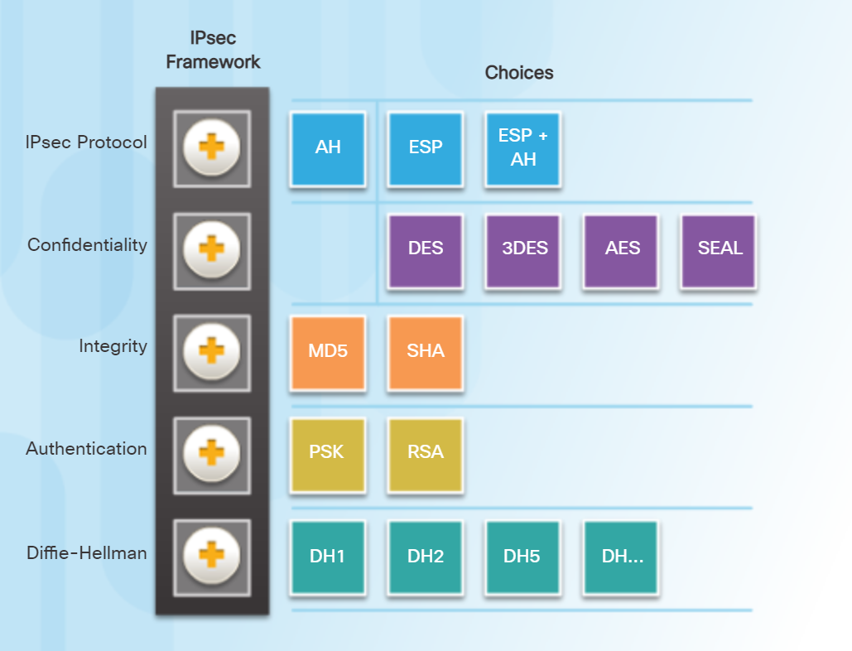

Choices increase in security as you go right

**Necessary for VPN Configuration!!!!**

The securityk9 package is **required** for VPNs to be configured (includes all crypto features)

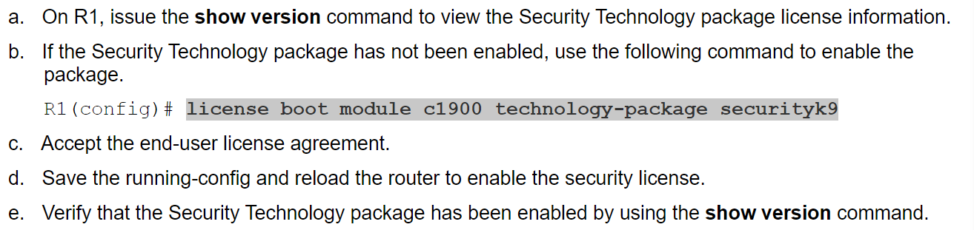

***Show version* - MAKE SURE securityk9 package and license is being used**

**Command to enable it: *license boot module c1900 technology-package securityk9***

Use the ***do reload*** command to apply it

**show crypto ipsec sa**

**show crypto isakmp sa**

**Site-to-Site VPN Configuration:**

Basic steps **(USING EXAMPLES OF CHOICES)**

1. **Create ACL**

* *Access-list 100 Permit ip *source network* to *destination network\**
* Picture MIGHT be another way to do it. Honestly, I don't think so

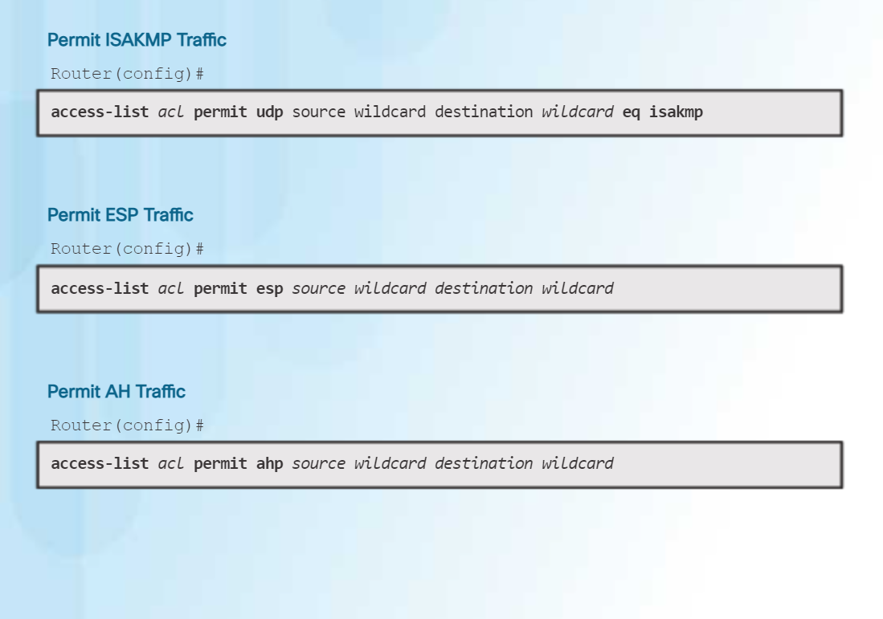

When in ISAKMP policy configuration mode, the SAs for the IKE Phase 1 tunnel can be configured. Use the mnemonic **HAGLE** to remember the five SAs to configure:

* **H**ash
* **A**uthentication
* **G**roup
* **L**ifetime
* **E**ncryption

1. **ISAKMP policy (Phase1) (LOOK AT CHART ON NEXT PAGE)**

* *crypto isakmp policy #*
  + ***encryption*** *(choice; typically* ***AES 256****)*
  + ***authentication*** *(choice; typically* ***pre-share****)*
  + ***group #***(**5** is highest in pt, real-world can go up to 14)
  + *Other commands that might be needed below:*
    - ***lifetime*** 3600

**ISAKMP key**

* ***crypto isakmp key*** *(secretkey)* ***address*** *\*209.165.200.1\**
* *\*IP address of destination router’s outbound interface\**

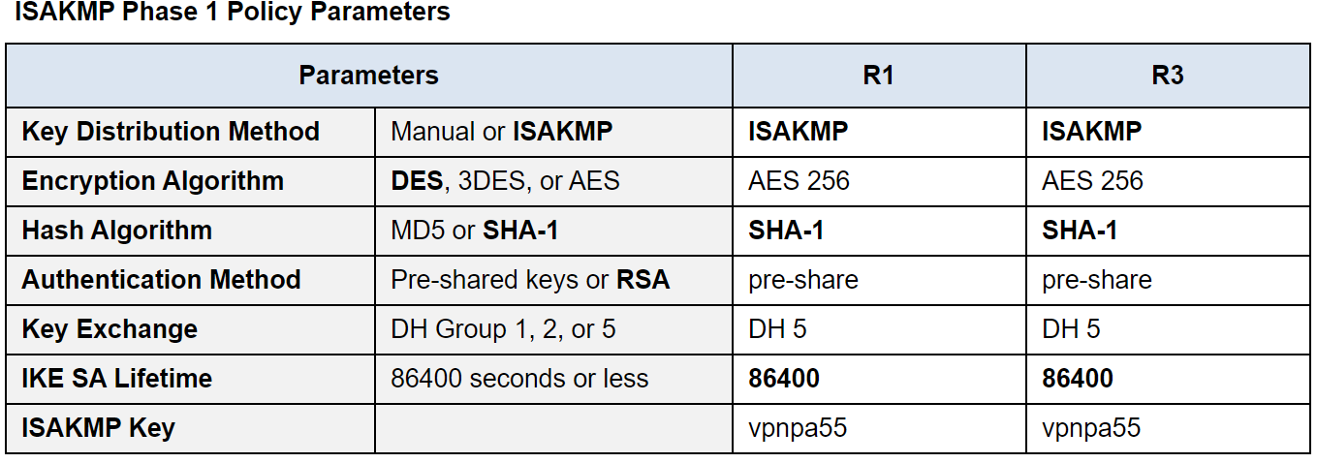

**(BOLDED CHOICES ARE DEFAULT VALUES FOR VPNs)**

1. **IPsec transformation-set (Phase2)**

* ***crypto ipsèc transform-set*** *(name) *esp-aes esp-sha-hmac\**
* *\*picking a particular transform set that both peers will be using\**

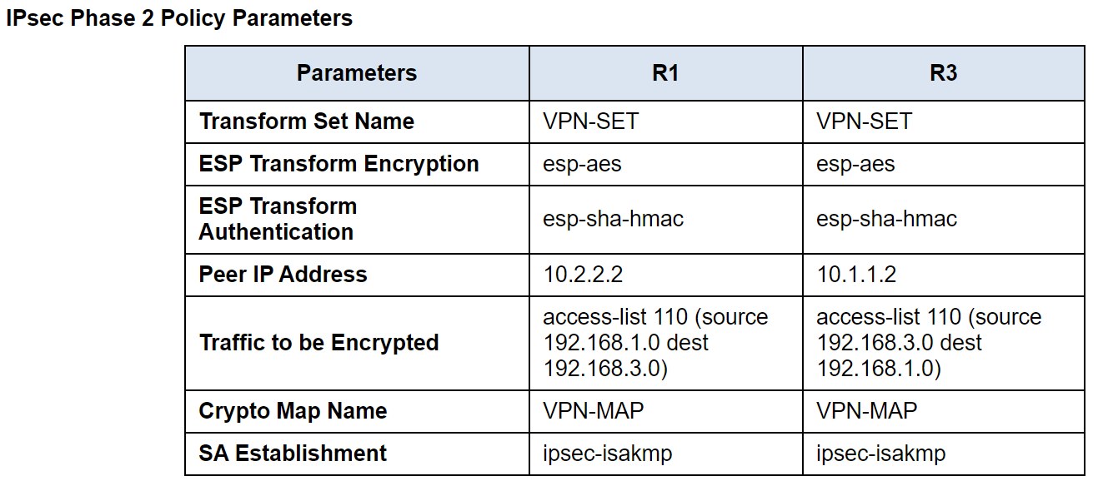

1. **Crypto map (tie it together)**

* ***crypto map*** *(name) (# of ISAKMP policy)* ***ipsec-isakmp***
* ***set peer*** *\*209.165.200.1* *destination router outbound interface\**
* ***set transform-set*** *(name of transform-set)*
* ***match address*** *(# of the Access list)*

1. **Int g0/0 *aka the outbound interface of the router your on\***

**-apply the crypto map**

* ***crypto map*** *(name of crypto map)*

**Remote-access VPNs**

* Used to allow end devices (PCs, phone) to access the company’s internal resources security over the internet
* Uses TLS (Transport layer security)
  + TLS provides security for HTTPS
  + TLS Formerly known as SSL
* VPN client software is installed on provided employee laptops and form secure tunnels with a company’s router acting as a TLS server
* End-user can securely access resources on the internal network without being directly connected to it

**Site-to-Site vs Remote-Access VPN**

| **Site-to-Site VPNs** | **Remote-Access VPNs** |
| --- | --- |
| Typically use IPsec | Typically use TLS. |
| Provide service to many devices within the sites they are connecting. | Provide service to the end device the VPN client software is installed on. |
| Typically used to permanently connect two sites over the Internet. | Typically used to provide on-demand access for end devices that want to securely access company resources while connected to a network that is not secure. |

# ASAs (Adaptive Security Appliances) aka Firewalls

* The ASA is a Cisco brand Next-generation firewall that combines typical firewall security with VPN and Intrusion prevention technologies.
* **Security levels-** trustworthiness of an interface, helps distinguish inside vs outside networks.
  + Higher security level = more trustworthy
  + 0 is the lowest level and is untrustworthy, assign to outside network
  + 100 is the highest level and is very trustworthy, assign to inside network
  + Higher to the lower level is outbound traffic and lower to the higher level is inbound traffic.
  + Outbound traffic is allowed and inspected by default, returning traffic is allowed due to stateful packet inspection, inbound traffic not returning will be denied unless an ACL is made to allow it.

# ASA Configuration

* Similar to IOS configs (see command differences below for basics)
* Some unique features like no do command (Also see below)

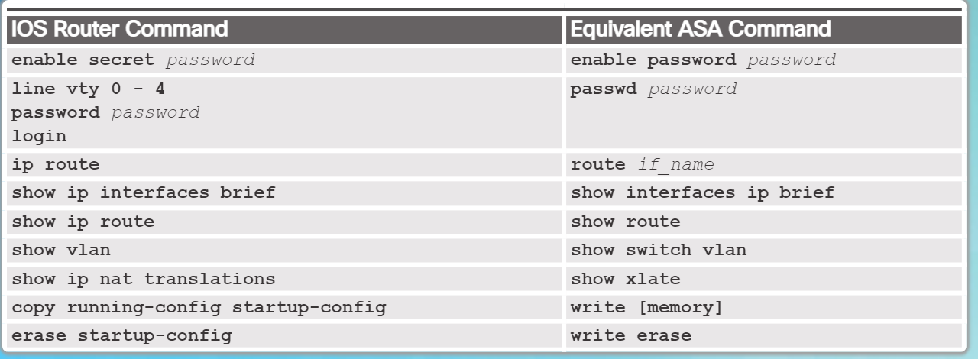

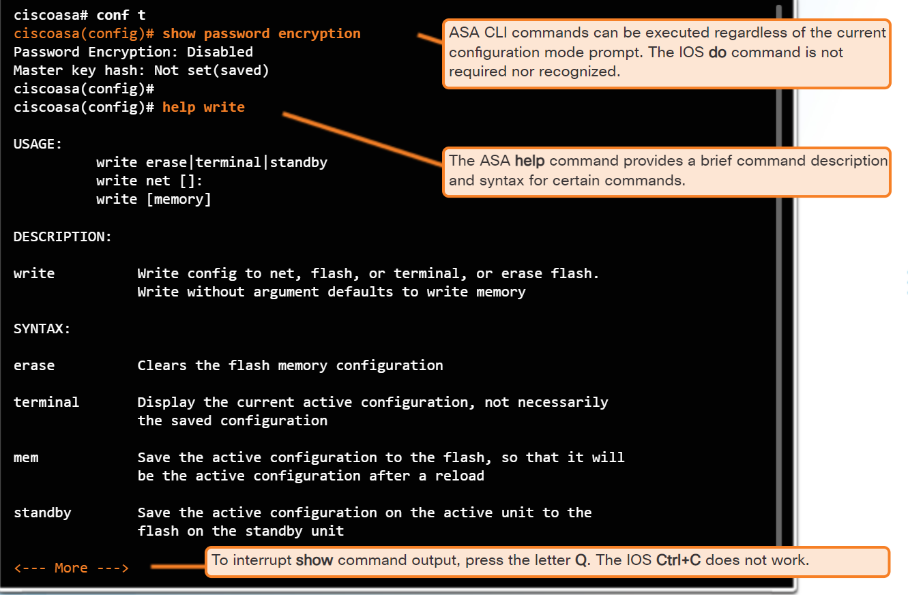

* ASA usually has default config, reset to default with  **configure factory-default**

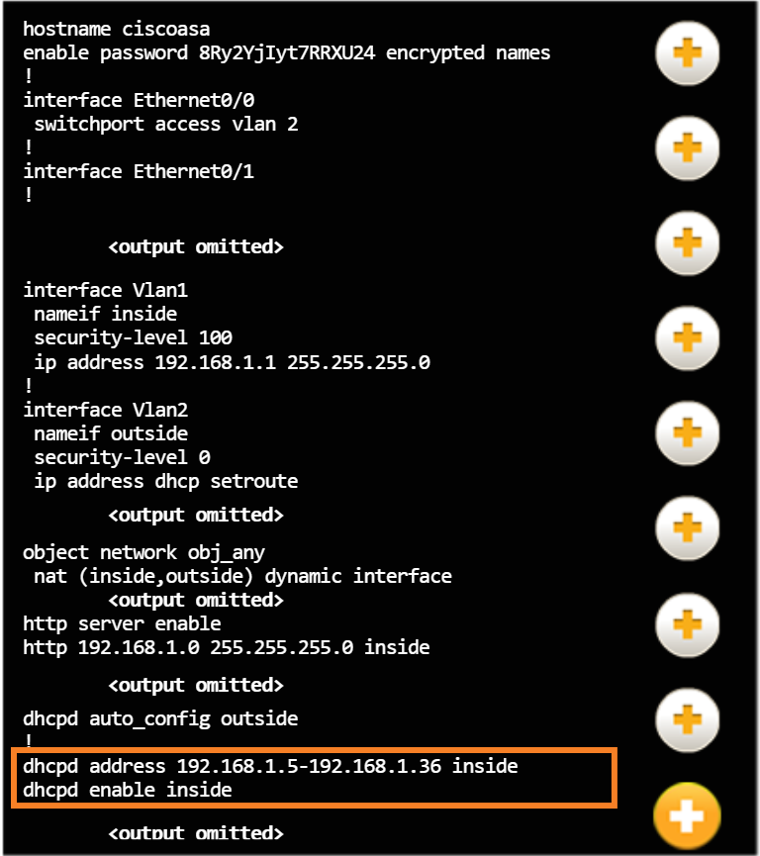

Enter Global Config Mode:

* Ciscoasa> **enable**
* Press enter when prompted for password
* If needed, **clock set** for time
* **Conf t**

Basic Config Settings Below:

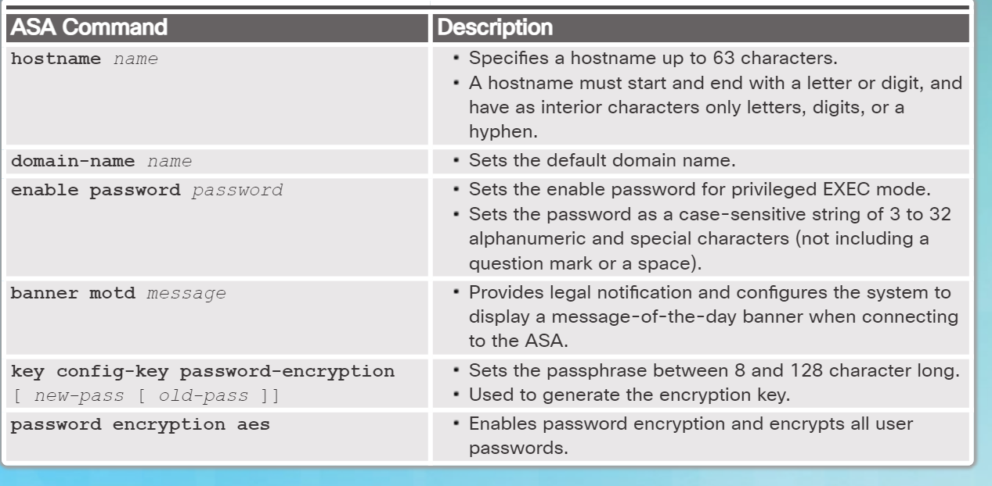

* Determine is password encryption is enabled with **show password encryption**

Config VLAN interface commands below:

* The name is either inside or outside

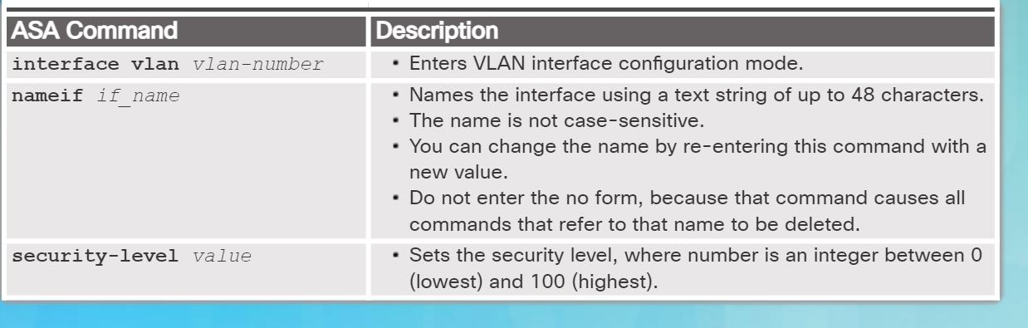

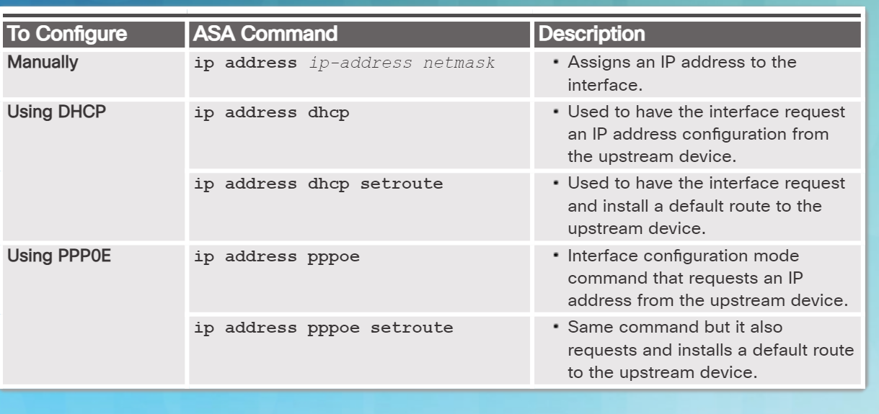

Need to Assign the layer 2 ports to VLANs

* Go into interface ***int e0/0***
  + ***Switchport access vlan #***
  + ***No shut***
  + ***exit***

Commands for Vlan troubleshooting ASA

* ***Show switch vlan***
* ***Show int ip br***
* ***Show ip addr***

A default static route **MUST** be configured unless using DHCP**\***

* ***Route*** *{interface-name}* ***0.0.0.0 0.0.0.0*** *{next-hop-ip-address}*
* Ex:***route outside 0.0.0.0 0.0.0.0 209.165.200.255***
* Verify with: ***show route***

***\****The ASA would be configured as a DHCP client where it would receive and install a default route from the upstream device.

Telnet or SSH is **required** to manage the ASA **remotely.**

Telnet Configuration Commands:

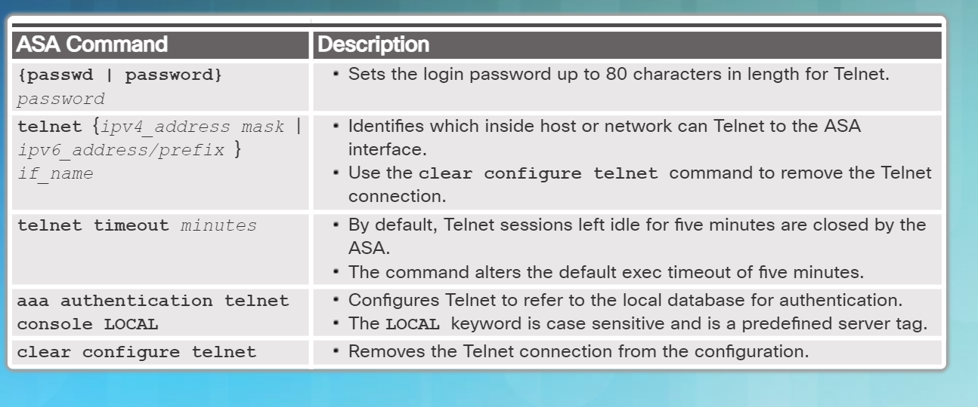

*the aaa command overrides the password command

Example: (Verification with: ***show run telnet)***

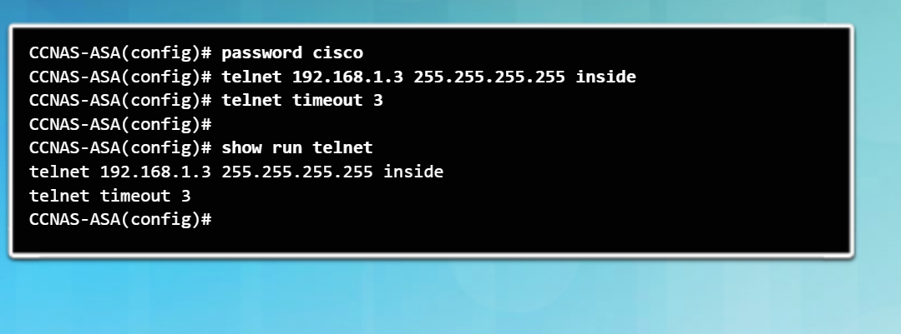

SSH Configuration Commands (**Always use SSH for ASA security unless otherwise specified):**

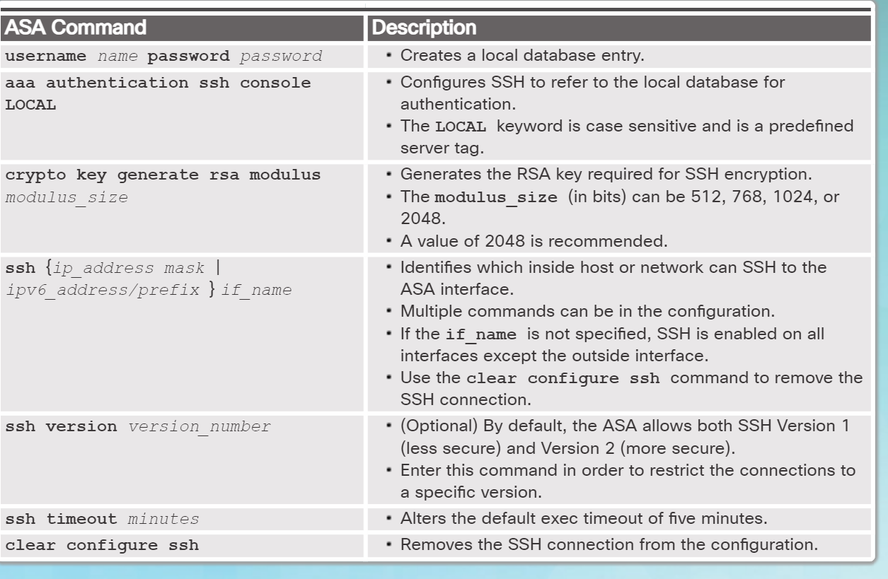

Example: (Verification with: ***show ssh)***

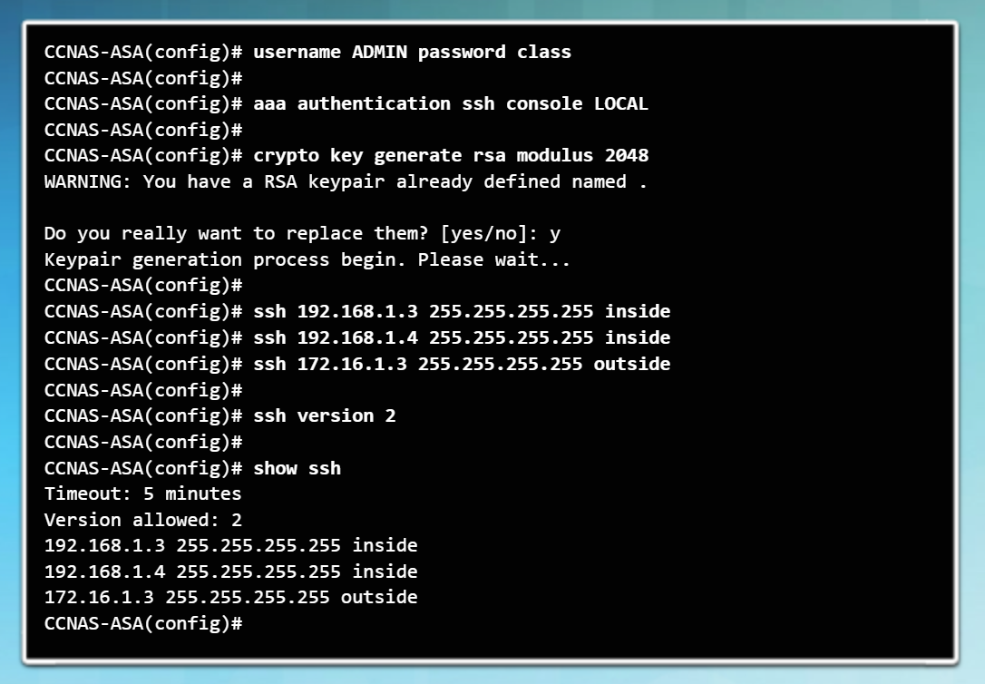

NTP is a service for ASAs to obtain date and time. NTP Configuration commands:

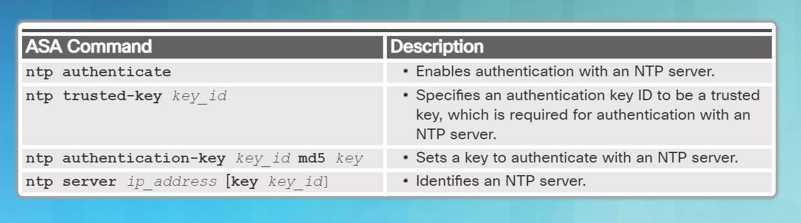

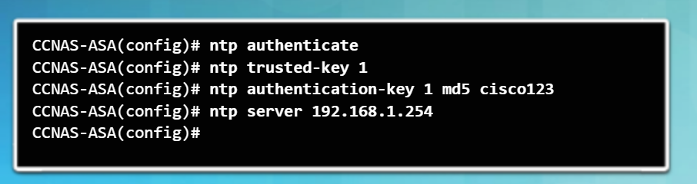

Verify NTP with ***show NTP status*** and ***show NTP associations***

DHCP Configuration Commands (Configuring the ASA as a DHCP server):

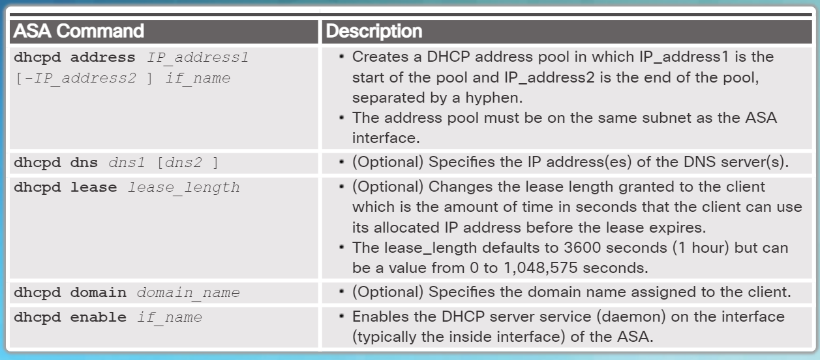

Example:

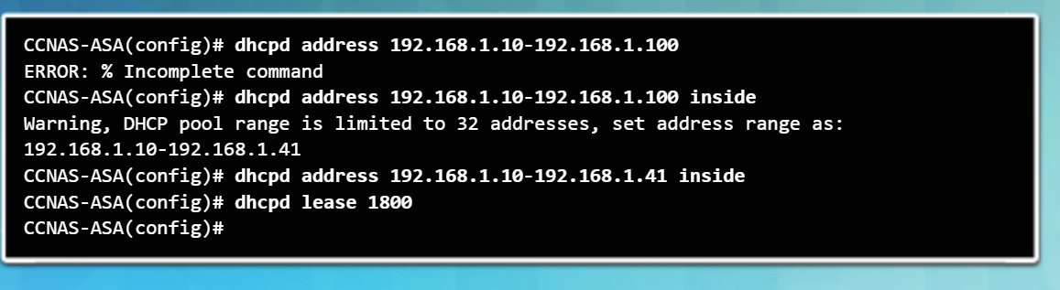

If the ASA outside interface was configured as a DHCP client, then the command ***dhcpd auto_config outside*** can be used to pass DHCP info the DHCP inside clients

Verify DHCP with:

* ***show dhcpd state***
* ***Show dhcpd binding***
* ***Show dhcpd statistics***

*To clear the DHCP bindings or statistics, use the* ***clear dhcpd binding*** *or* ***clear dhcpd statistics*** *command.*

## Objects and Object Groups:

An **object** is a set of data that can be used in multiple configurations. When edited, all configurations containing the object will change. Objects can be used in NAT, Access-lists, and Object groups.

An **object group** is a collection/grouping of the objects that makes it so that instead of using many different statements in an ACL, we can refer to an object group to make the ACL easier to read and understand.

There are two types of objects that can be configured:

* **Network object** - Contains a single IP address and subnet mask. Network objects can be of three types: host, subnet, or range. A network object is configured using the **object network** command.
* **Service object** - Contains a protocol and optional source and/or destination port. A service object is configured using the **object service** command.

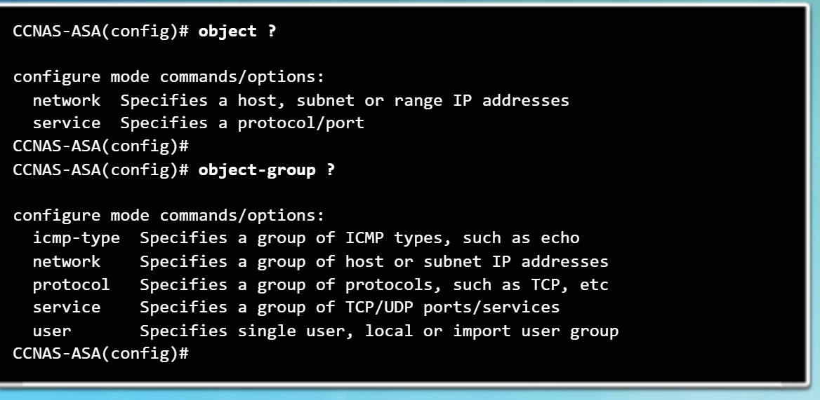

Explanation of Object Groups:

* **icmp-type** can be used to select all the different ICMP types, for example, echo, echo-reply, traceroute, unreachable, etc.
* **network** is used to select IP addresses and/or network addresses.
* **protocol** lets you select an entire protocol. For example, TCP, UDP, GRE, ESP, AH, OSPF, EIGRP, and many others.
* **security** is used for Cisco TrustSec.
* **service** is used to select TCP and/or UDP port numbers.
* **user** is to select local user groups for Identity Firewall.

The following guidelines and limitations apply to object groups:

* Objects and object groups share the same name space.
* Object groups must have unique names.
* An object group cannot be removed or emptied if it is used in a command.
* The ASA does not support IPv6 nested object groups.

**Configuring Network Objects:**

* **object network** *object-name*
* A network object name can contain only one IP address and mask pair aka one statement in the object. Entering a second pair would **replace** the first.
* Remove an object by using no in front or ***clear config object network*** to remove all of the objects
* Define Network objects in one of the three ways below.

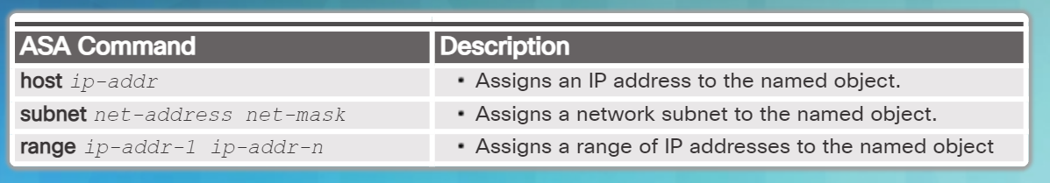

Example of creating and replacing a Networking Object:

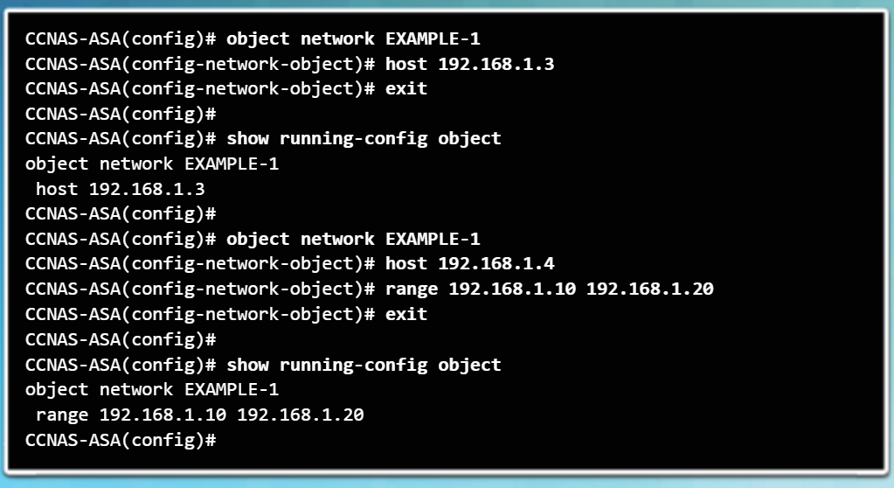

* Verify with ***show running-config object***

**Configuring Service Objects:**

* **object service** *object-name*
* A service object name can only have one protocol and port aka one statement in the object. Entering a different protocol and port would **replace** the existing configurations.
* Remove an object by using no in front or ***clear config object service*** to remove all of the objects
* Service objects can have one of the options below

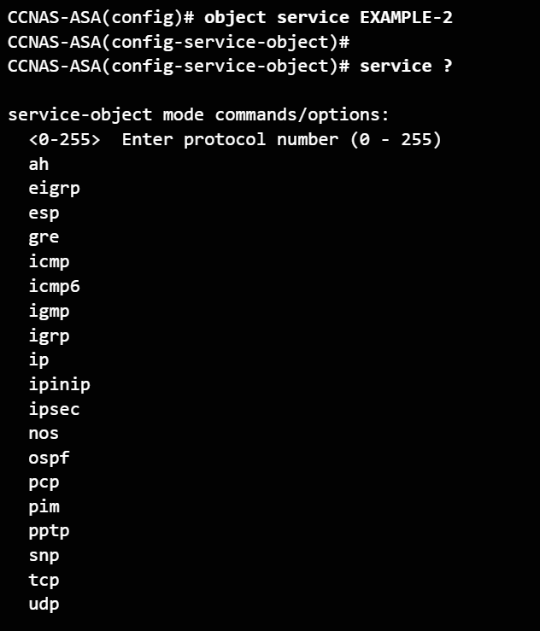

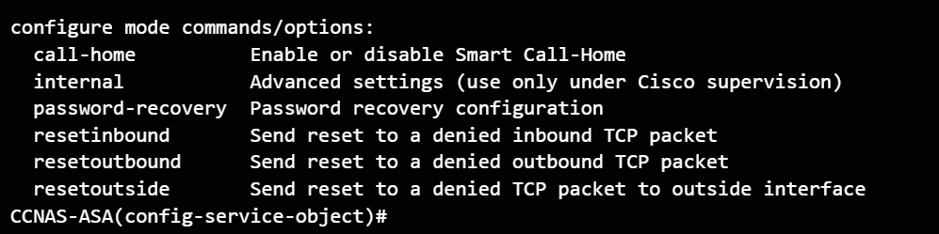

Below are common service options picked. Use of operators such as eq(equal), neq(not equal), gt(greater than), lt(less than), and range

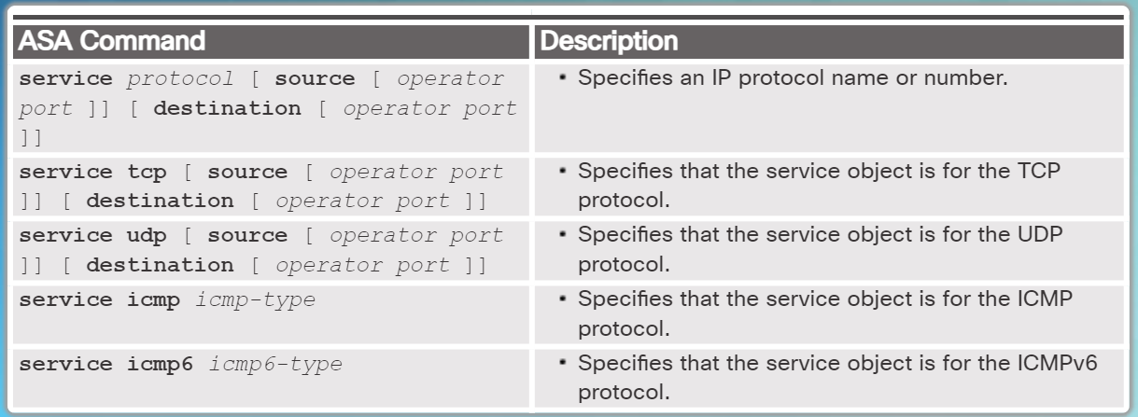

Example of creating and replacing a Service Object

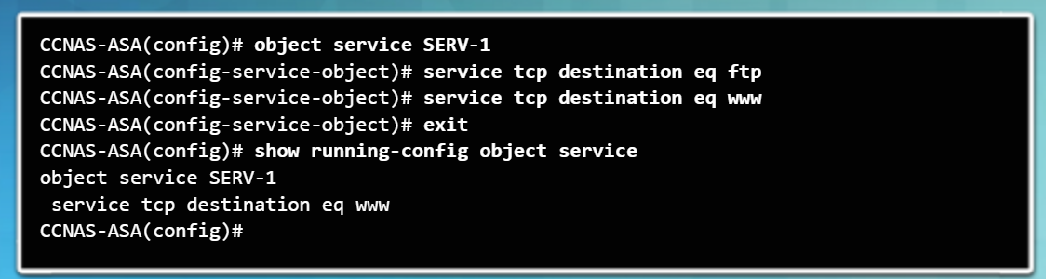

* Verify with ***show running-config object service***

**Configuring Common Object Groups:**

**Network Object Group:**

* ***Object-group network*** *grp-name*
* Add network objects to the network group using the ***network-object***and ***group-object*** commands.
* A network object group **CANNOT** be used to Implement NAT, only a network object can be used.

Example of Network Object Group Configuration:

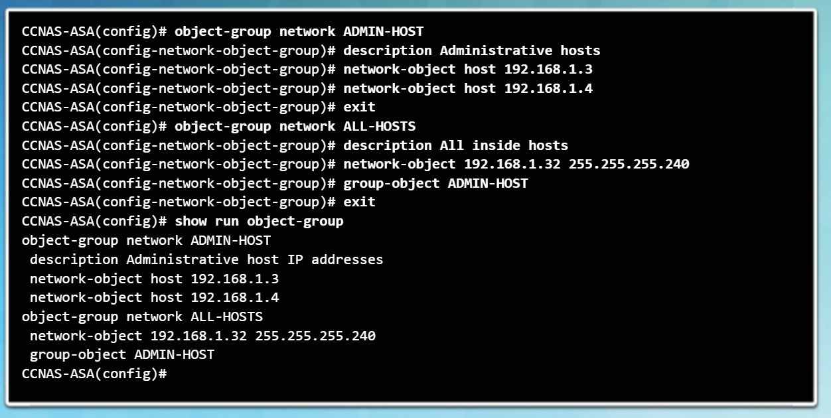

**ICMP Object Group:**

* ***Object-group ICMP-type*** *grp-name*
* Add ICMP objects to the ICMP group using the ***ICMP-object***and ***group-object*** commands.

Example of ICMP Object Group Configuration:

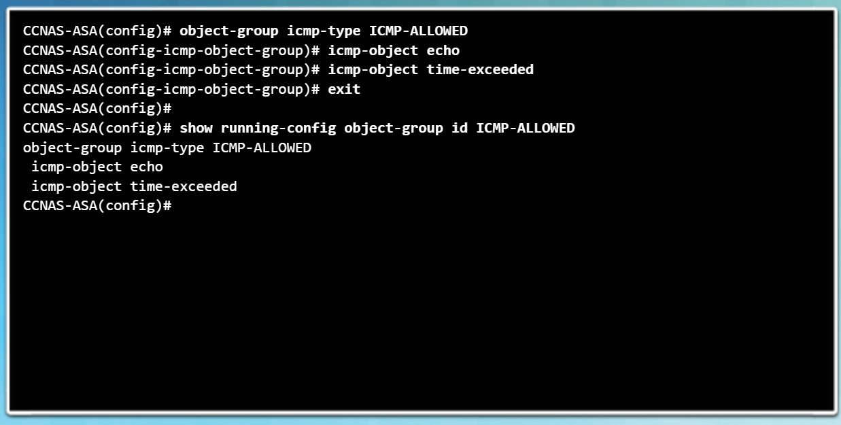

**Service Object Group:**

* ***Object-group service*** *grp-name*
* Add service objects to the service group using the ***service-object***and ***group-object*** commands.
* For TCP/UDP specifically, use the command ***Object-group service tcp/udp***
  + This optional specification will define port specifications like “eq smtp” and “range 2000 2010”
  + Add port objects to the service group using the ***port-object***and ***group-object*** commands.

Example of Service Object Group Configuration:

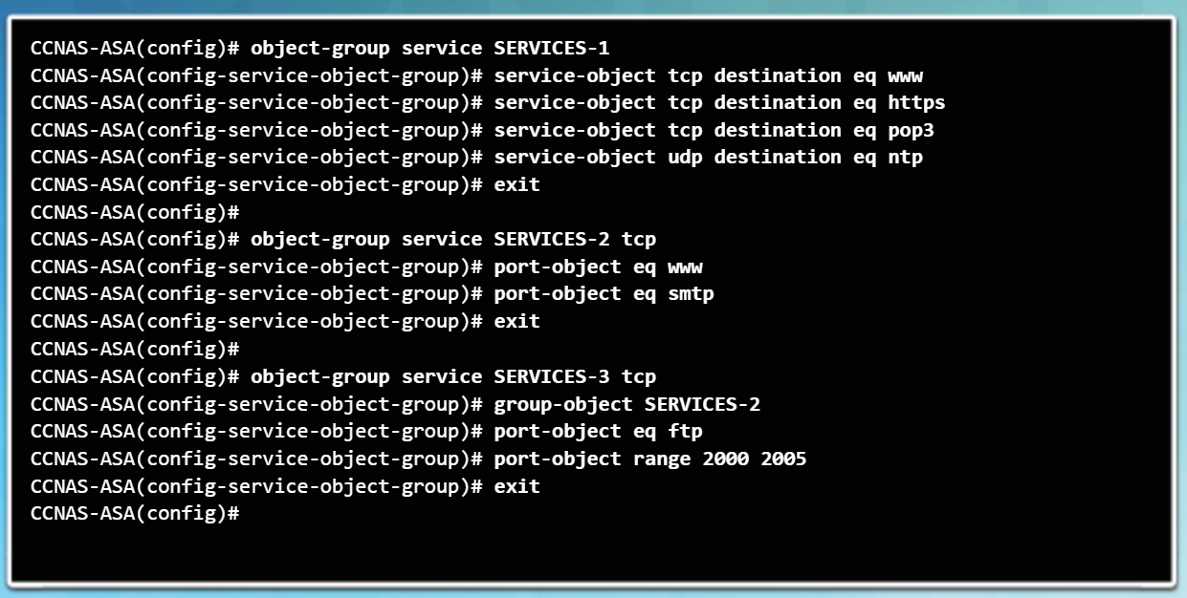

Remove all the object groups from the configuration with the ***clear configure object-group*** command.

Verify group object configurations with the ***show running-config object-group*** command.

Practical examples of object groups will be presented when configuring ACLs and NAT. The ASA does not support IPv6 nested object groups.

# ASA ACLs:

* Many similarities to IOS ACLs
  + Both are made up of ACEs, processed sequentially from the top down, and there is an implicit **deny any** at the bottom. Additionally, the rule of only one ACL per interface, per protocol, per direction, still applies.
* **Differences:**
  + ASA ACLs use a network mask (255.255.255.0) instead of a wildcard mask (0.0.0.255)
  + Always named instead of numbered
  + Interface security levels apply access control without an ACL configured

Types of filtering:

* **Through-traffic filtering**
  + Traffic that is passing through the security appliance from one interface to another interface. The configuration is completed in two steps. The first step is to set up an ACL. The second step is to apply that ACL to an interface.
* **To-the-box-traffic filtering**
  + Also known as a management access rule, to-the-box-traffic filtering applies to traffic that terminates on the ASA. Introduced in version 8.0 to filter traffic destined for the control plane of the ASA. It is completed in one step but requires an additional set of rules to implement access control.

ASAs defer due to interface security levels

* By default, security levels apply access control without an ACL configured.
* For instance, traffic from a more secure interface, such as security level 100, is allowed to access less secure interfaces, such as level 0. Traffic from a less secure interface is blocked from accessing more secure interfaces.

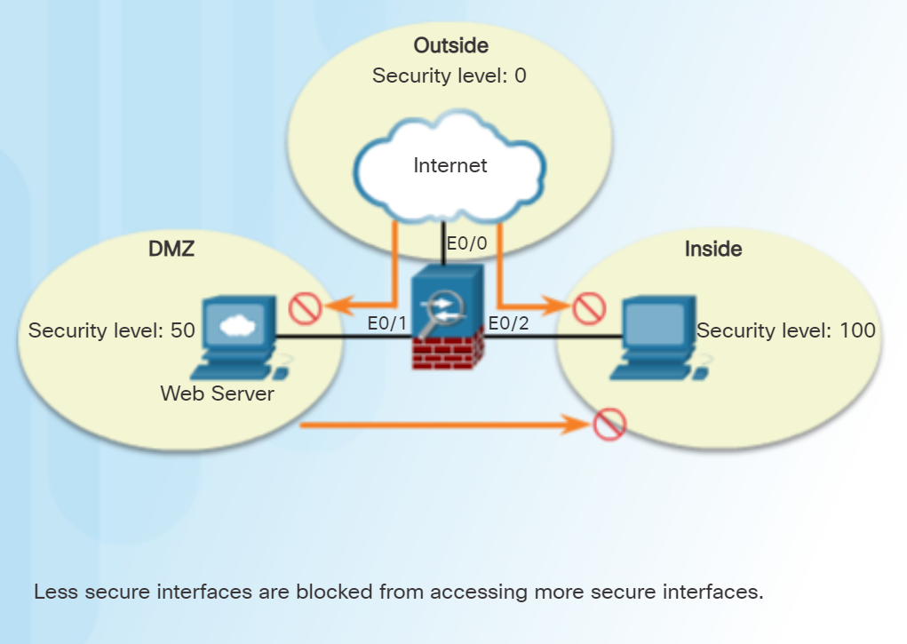

Command to allow connectivity between interfaces with the same security levels:

* ***same-security-traffic permit inter-interface***

Command to enable traffic to enter and exit the same interface, such as when encrypted traffic enters an interface and is then routed out the same interface unencrypted:

* ***same-security-traffic permit intra-interface***

# **Types of ASA ACLS:**

Extended ASA ACL:

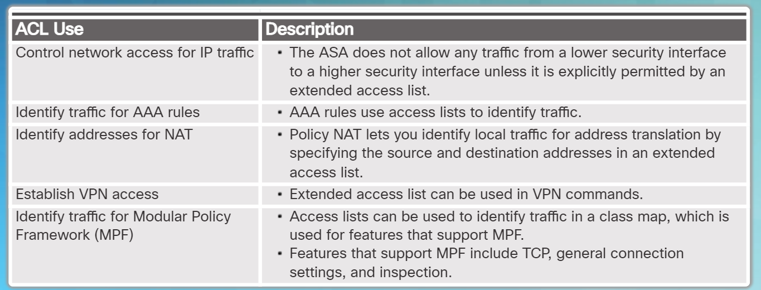

Standard ASA ACL:

* Important to note that it uses the **destination ip addr of the OSPF network** instead of source address

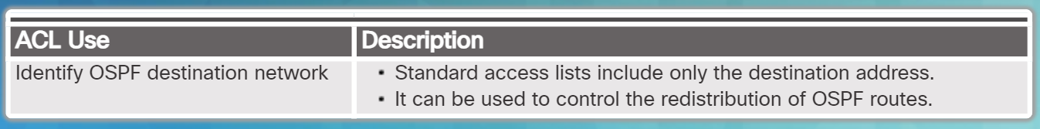

Other Types:

* **EtherType access list** - An EtherType ACL can be configured only if the security appliance is running in transparent mode.
* **Webtype access list** - Used in a configuration that supports filtering for clientless SSL VPN.
* **IPv6 access list** - Used to determine which IPv6 traffic to block and which traffic to forward at router interfaces.

Learn ACL syntax with ***help access-list***

Understanding ASA ACL Syntax and options:

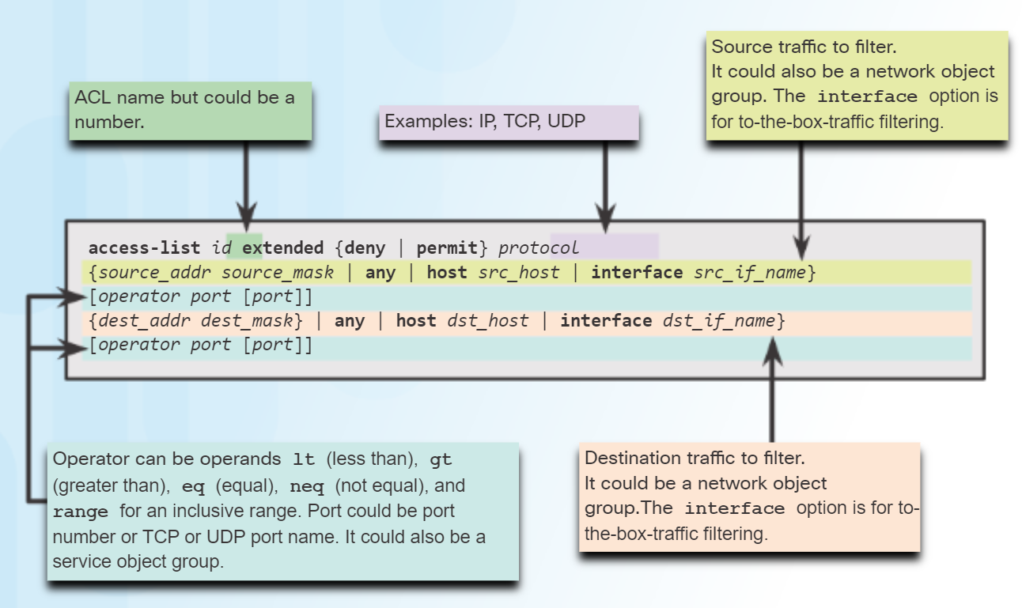

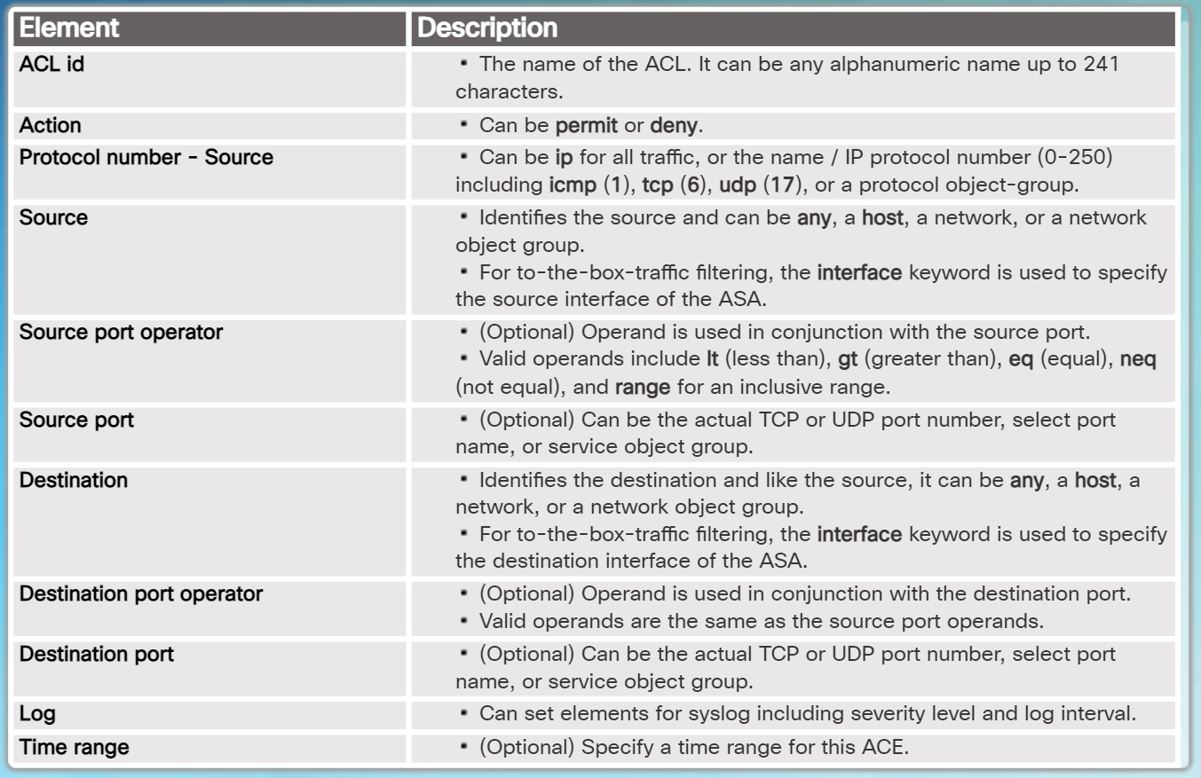

**Applying an ASA ACL:**

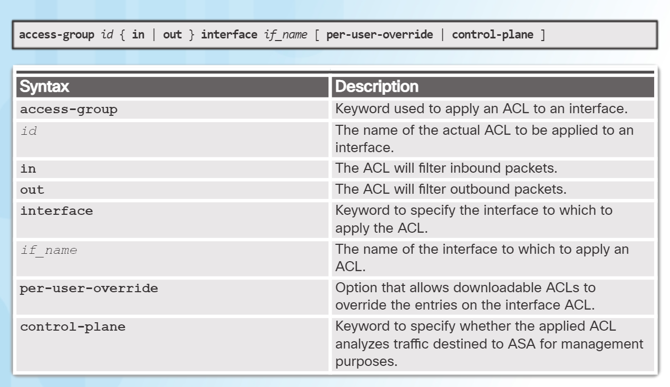

Verify ACLs using the ***show access-list*** and ***show running-config access-list*** commands.

To erase a configured ACL, use the ***clear configure access-list*** *id* command.

**ACL Examples:**

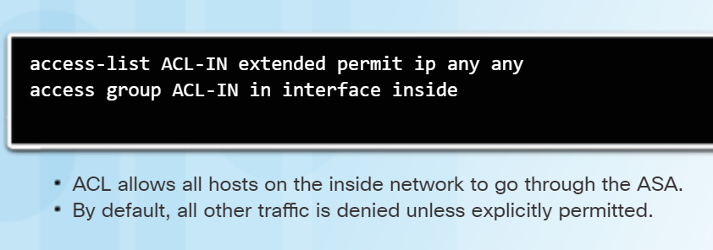

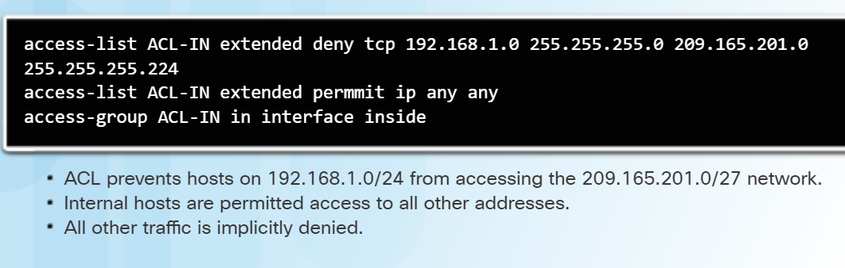

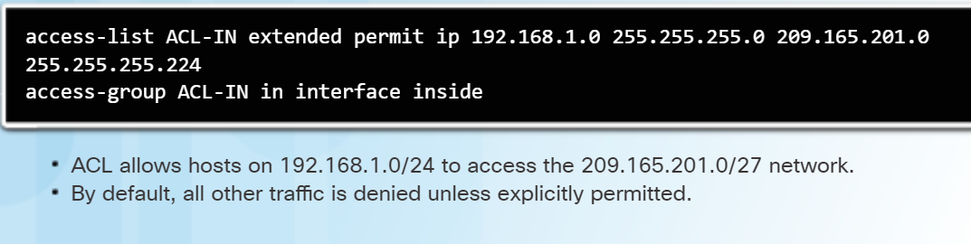

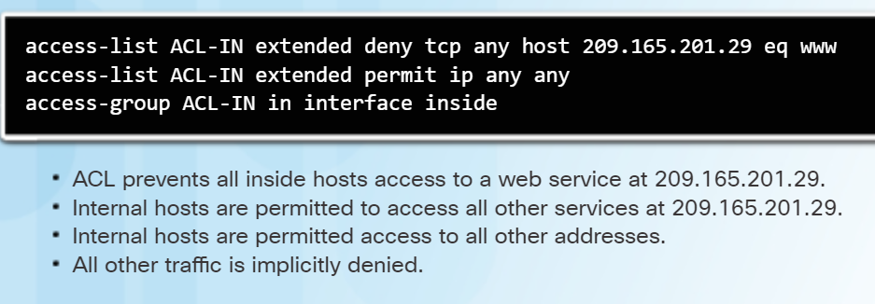

**ASA ACLs and Object Groups:**

Condensed ACL syntax to use with object groups below

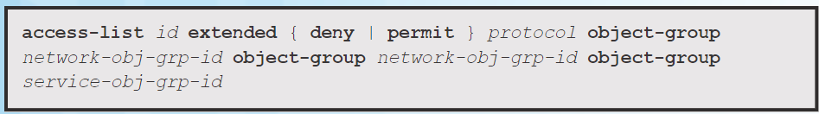

Using the topology below to exemplify how using object groups makes ACLs easier.

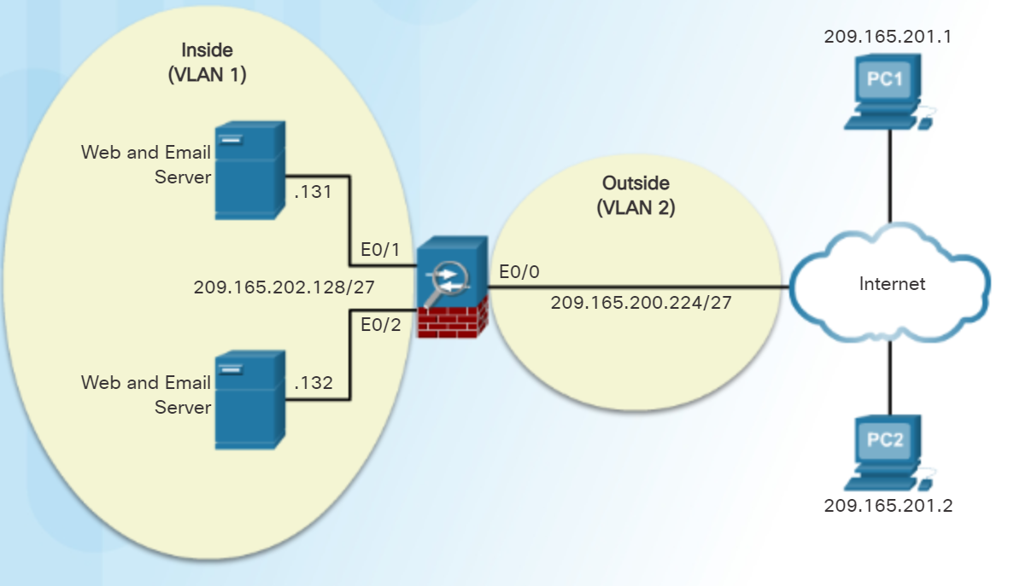

List of ACE statements (commands) that you would put in normally:

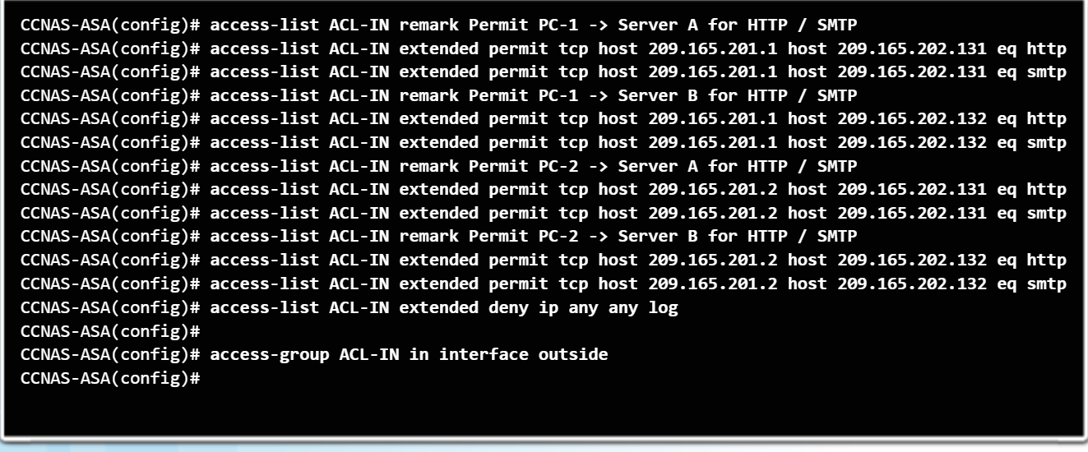

Normal Access list that would have many statements:

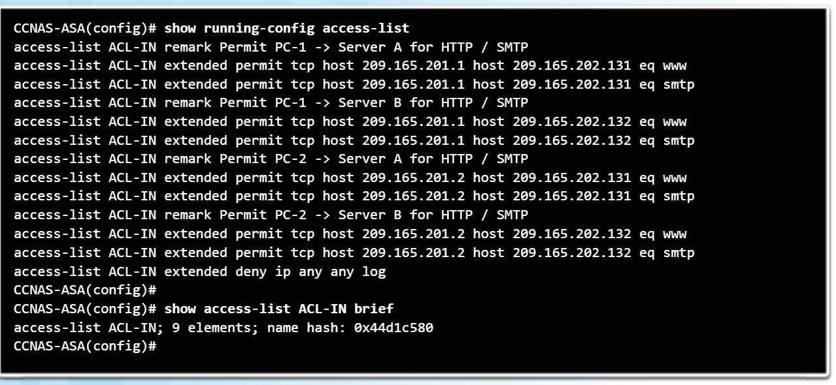

Using **Object Groups** instead of 9 ACE statements in the ACL:

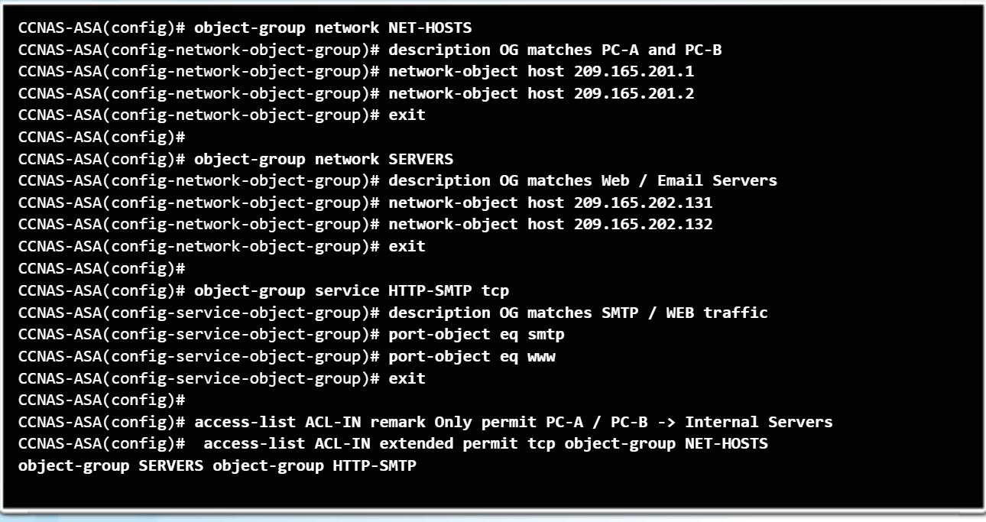

Improved Access list using Object Groups that is easier to read:

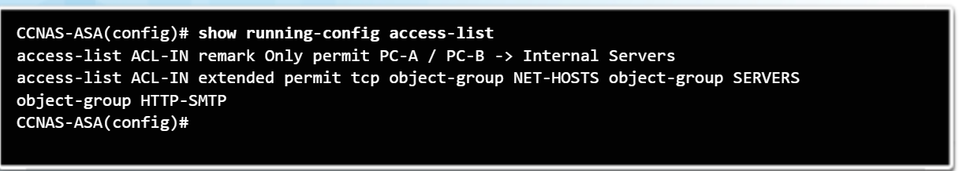

# **ASA NAT**

Nat supported by the ASA:

* **Dynamic NAT** – This is a many-to-many translation. Usually an inside pool of private addresses requiring public addresses from another pool.
* **Dynamic PAT** – This is a many-to-one translation. This is also known as NAT overloads. Usually an inside pool of private addresses overloading an outside interface or outside address.
* **Static NAT** – This is a one-to-one translation. Usually an outside address mapping to an internal server.
* **Policy NAT** - Policy-based NAT is based on a set of rules. These rules can specify that only certain source addresses intended for specific destination addresses and/or specific ports will be translated

Referred to as **Network object NAT**

**Configuring Dynamic NAT:**

Two network objects needed:

* A network object identifying the pool of public IP addresses into which internal addresses are translated. These are identified using **range** or **subnet** network object commands.
* The second network object identifies the internal addresses to be translated and then binds the two objects together. These are identified using the **range** or **subnet** network object commands. The two network objects are then bound together using the **nat** (*real-ifc*, *mapped-ifc*) **dynamic** *mapped-obj* network object command.

Example of Dynamic NAT configuration: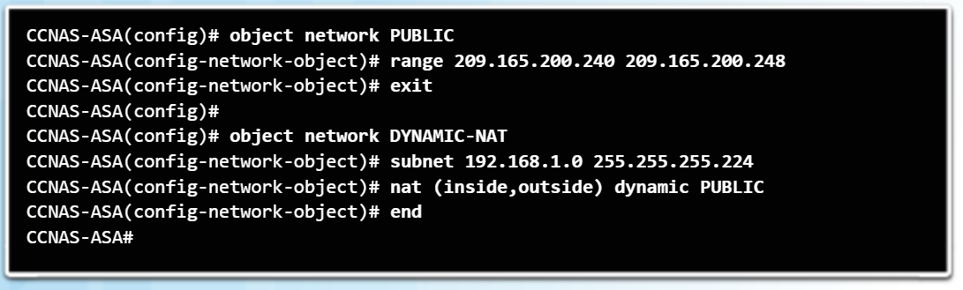

**Necessary to have** Configuration to allow return ICMP traffic from outside hosts:

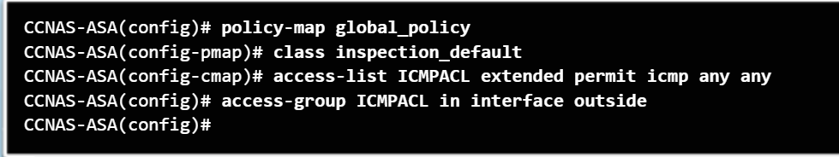

After the inside host pings the outside host, verify the network address translation using the ***show xlate*** command

Additional information can be gathered using the ***show nat*** and ***show nat detail*** commands.

**Configuring Dynamic PAT:**

* Actual external IP address is configured and overloaded instead of the ASA interface IP address.
* Only1 network object is needed when overloading the outside interface

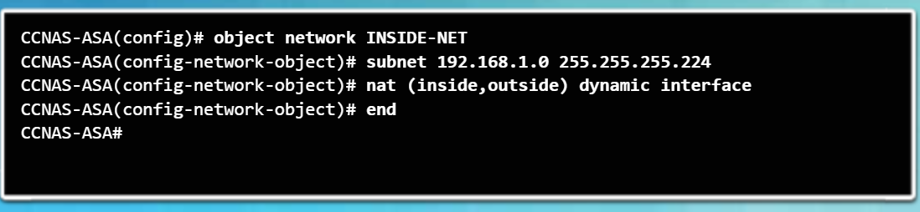

**Configuring Static NAT:**

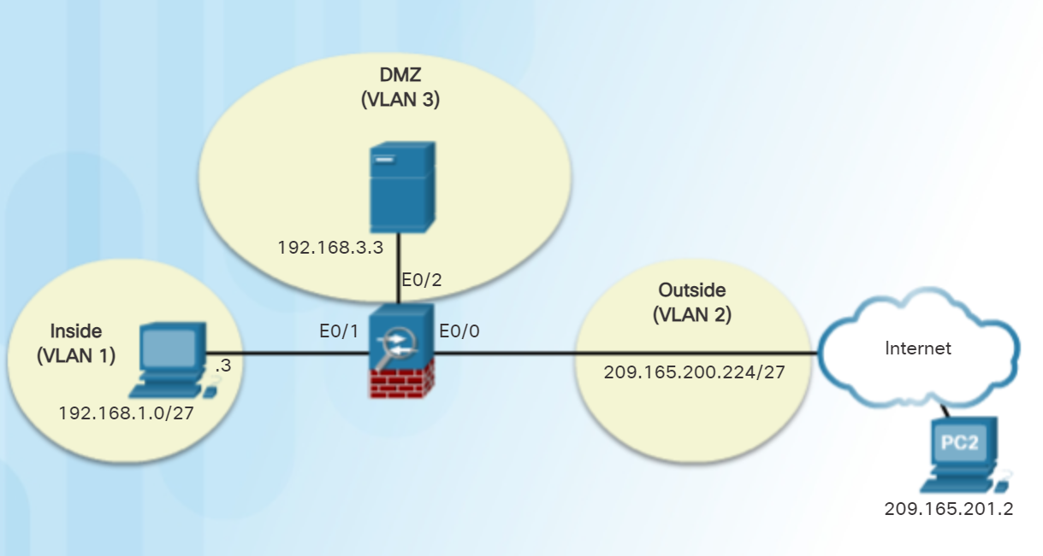

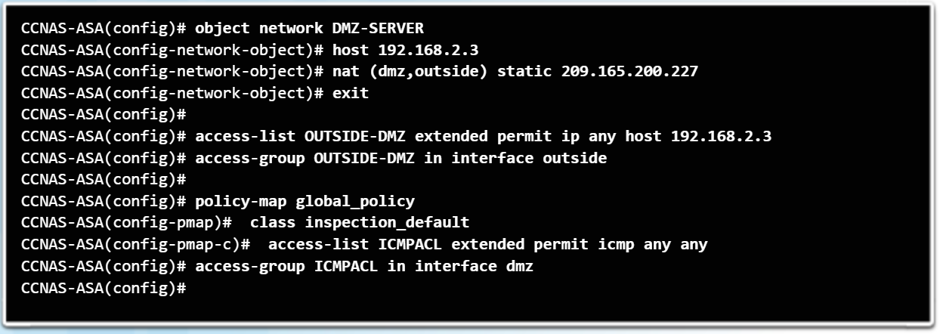

**Configures the DMZ interface on ASA**

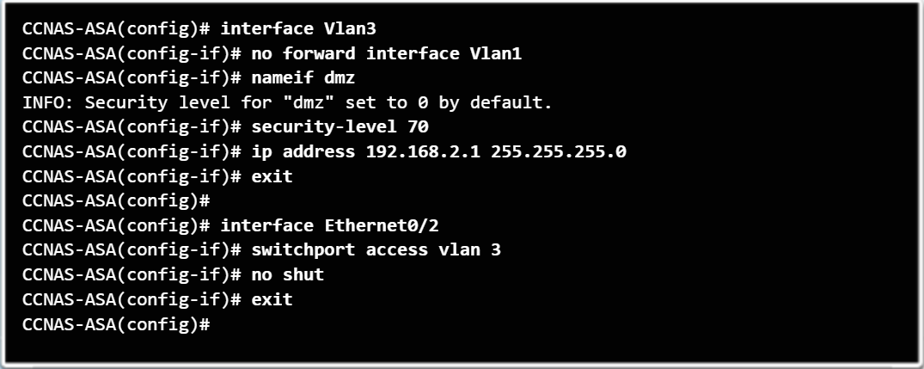

* ACL is required for the translation to work
* Verify translations with ***show xlate*** and ***show nat detail***
* ***Clear nat encounters*** for testing NAT
* No forward interface to inside users for DMZ (**COMMAND ABOVE)**

**AAA through ASA:**

* Using AAA only, authenticated and authorized users can be permitted to connect through the ASA.
* The ASA can authenticate all administrative connections to the ASA, including Telnet, SSH, console, ASDM using HTTPS, and privileged EXEC.
* ASA devices do not support local authentication without using AAA.

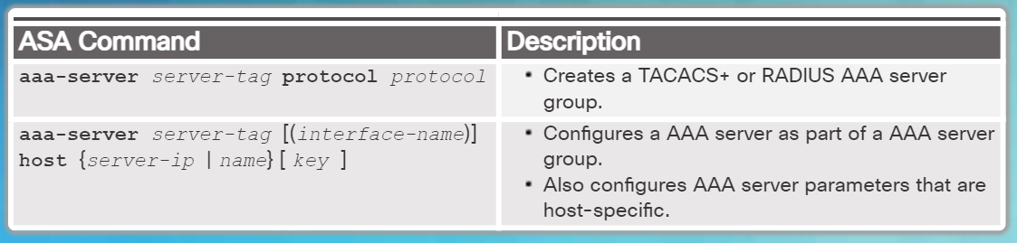

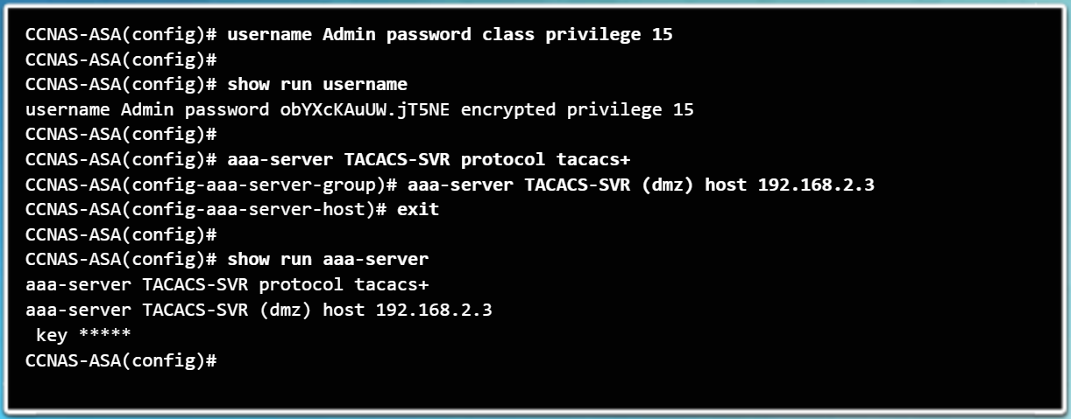

* To erase a user from the local database, use the **clear config username** [*name*] command. To view all user accounts, use the **show running-config username** command.
* Server based AAA is better to use with multiple devices.
* To erase all AAA server configurations, use the ***clear config aaa-server*** command
* Use the ***enable*** command, then use the ***aaa authentication console***
* The command syntax is ***aaa authentication { serial | enable | telnet | ssh | http } console { LOCAL | server-group [ LOCAL ]} command.***
* ***clear config aaa command.*** To view all user accounts, use the ***show running-config username***

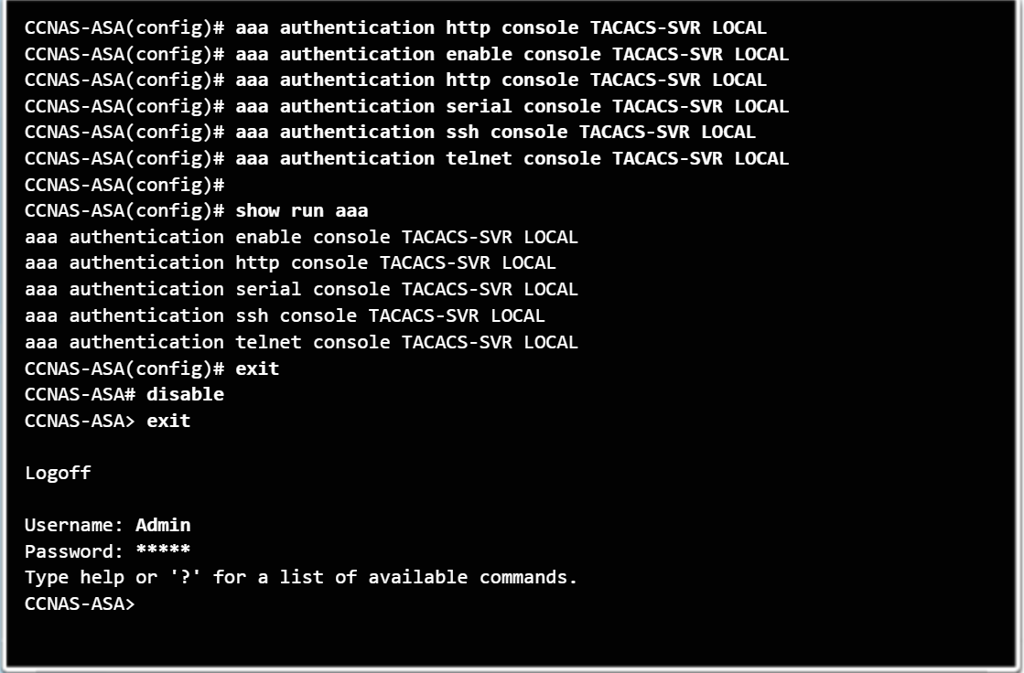

**Service Policy for ASA**

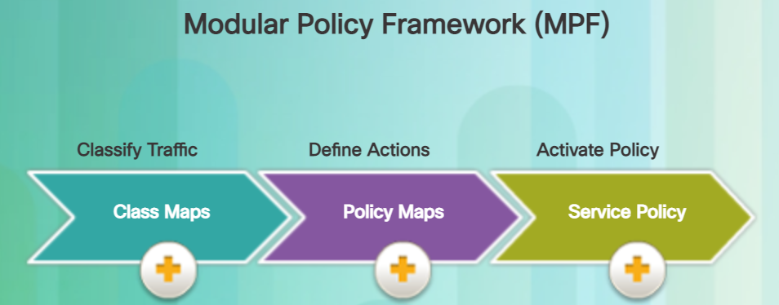

A Modular Policy Framework (MPF) configuration defines a set of rules for applying firewall features, such as traffic inspection and QoS, to the traffic that traverses the ASA.

There are four steps to configure MPF on an ASA:

* **Step 1.** (Optional) Configure extended ACLs to identify granular traffic that can be specifically referenced in the class map. For example, ACLs can be used to match TCP traffic, UDP traffic, HTTP traffic, or all traffic to a specific server.
* **Step 2.** Configure the **class map** to identify traffic.
* **Step 3.** Configure a **policy map** to apply actions to those class maps.
* **Step 4.** Configure a **service policy** to attach the policy map to an interface.

**Configuring Class maps:**

* Identify Layer ¾ traffic
* **class-map** *class-map-name* command.
* Variation of the class map command that is used for management traffic uses the **class-map type management** *class-map-name* command.
* Configure a description with the ***description*** command
* Traffic to match should be identified using the ***match any*** (matches all traffic) or ***match access-list*** *access-list-name* to match traffic specified by an extended access list.
* Only include one match command in the class map. (unless specified)
* The ASA also automatically defines a default Layer 3/4 class map identified in the configuration by **class-map inspection_default**. Identified in this class map is the **match default-inspection-traffic** which matches the default ports for all inspections. When used in a policy map, this class map ensures that the correct inspection is applied to each packet, based on the destination port of the traffic.
* Normally, the ASA does not use the port number to determine which inspection to apply. This provides flexibility to apply inspections to non-standard ports.
* To display information about the class map configuration, use the ***show running-config class-map*** command.
* To remove all class maps, use the ***clear configure class-map*** command.

Example of Class Map:

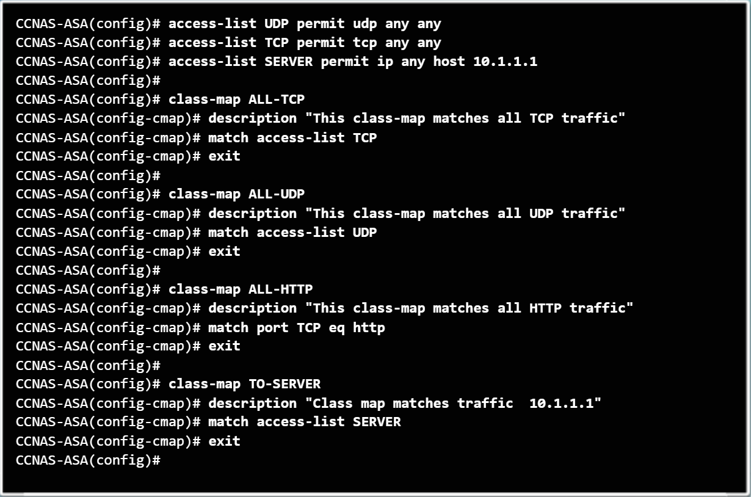

**Defining and activating Policy maps:**

* ***policy-map*** *policy-map-name* command.
* Applying actions to layer 3 and 4 traffic
* In policy-map configuration mode, config-pmap
  + ***description*** - Add description text.
  + ***class*** *class-map-name* - Identify a specific class map on which to perform actions.
* Max policy maps: 64
* There can be multiple Layer 3/4 class maps in one policy map, and multiple actions can be assigned from one or more feature types to each class map.
* The configuration includes a default Layer 3/4 policy map that the ASA uses in the default global policy. It is called global_policy and performs an inspection on the default inspection traffic. There can only be one global policy. Therefore, to alter the global policy, either edit it or replace it.
* Policy Map common commands
  + ***set connection*** - Sets connection values.
  + ***inspect*** - Provides protocol inspection servers.
  + ***police*** - Sets rate limits for traffic in this class.
* To display information about the policy map configuration, use the ***show running-config policy-map*** command.
* Use the ***clear configure policy-map*** command in global configuration mode, to remove all policy maps.

**Configuring Service Policy:**

* ***service-policy policy-map-name [ global | interface intf ]***

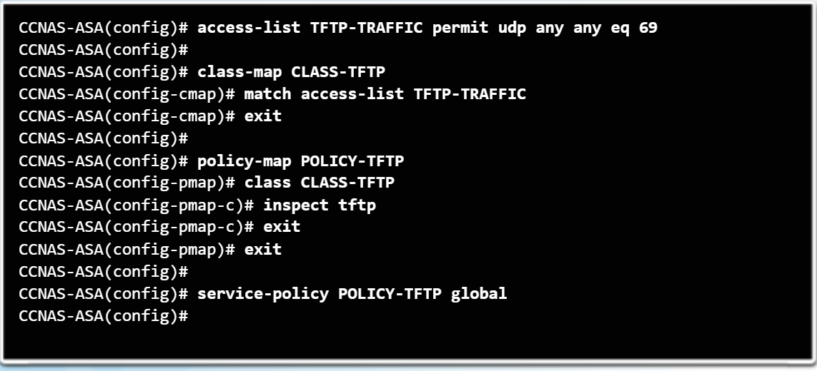

**ASA Default Policy:**

* Global policy that matches all default application inspection traffic and applies inspection to the traffic globally.
* Interface service policies take precedence over the global service policy for a given feature.
* To alter the global policy, an administrator needs to either edit the default policy or disable the default policy and apply a new policy.
* To display information about the service policy configuration, use the ***show service-policy*** or the ***show running-config service-policy*** command.
* Use the ***clear configure service-policy*** command in global configuration mode to remove all service policies. The ***clear service-policy*** command clears the service policy statistics.

# Sources/Other Checklists To look at if stuck:

[Indigo Cisco Checklist](https://docs.google.com/document/d/1vD8_Nuz2V_OtkTx1DJl0Bj-iRgH8FWIWSlNOc-eTlLw/edit?usp=sharing) (From a Team that went to Finals)

[Command Sheet](https://marshallcyberclub.github.io/resources/commands%20list.pdf) (Pretty useful I found it online)

[CCNA ALL I NEED](https://docs.google.com/document/d/1-dld9wzx_6c-68Ry0fThpMP06Gh6G8XizRrbrDEwGNs/edit?usp=sharing) (My CCNA learning Document)

[Cisco stuff.docx](https://docs.google.com/document/d/1kIFpL1bB-fXDFnf5o_O99kdwZXX5gEN-/edit?usp=sharing&ouid=109630843956033939644&rtpof=true&sd=true) (Basically a book of Cisco, super informational on basic to intermediate knowledge)

[Cisco Configuration Guide](https://docs.google.com/document/d/1slCA_c3vmRz83sP5lBf3tuAxfo_3aF0VP2ELwF2HYyI/edit?usp=sharing) (Useful configurations)

[Chale Cisco Notes](https://docs.google.com/document/d/1JhZfEezzyTBPK4lSkxuug-HPR_COmH3M3fLRiDc-3bQ/edit?usp=sharing) [Same Notes but on Word instead of Docs](https://loyolablakefield-my.sharepoint.com/:w:/g/personal/cmhale2023_loyolablakefield_org/EZ0F0xVjxKFGldnBhtxtezoBDs4jQOnGu_HIbTk9Bk9-zA?e=DHlJcZ)

(Notes from another student)

[Cisco](https://docs.google.com/document/d/1Zr0AHjR5YKBH1ndHMxJDDcq-kpf0rxR_ID2GtioOMIw/edit?usp=sharing) (My beginner checklist)

[Cisco Lesson Plan Stuff](https://docs.google.com/document/d/1HMSeKLG4uBR7IYdoTz81vb7qCjjD6Tn0rU4HPrLYpCM/edit?usp=sharing) (basics of lessons learned)

[Cisco Notes](https://docs.google.com/document/d/1JmKgmm74A_2t97jb_gleo6mOt-0Nnwoz07R5RctZDSU/edit?usp=sharing) (Brehm, a Cisco Teachers Notes)

[Cisco Notes](https://docs.google.com/document/d/1PPkxwhZcZkCyust7YcZhpvtfzNPp0pPzoRVq9ZH7Ny0/edit?usp=sharing) (Notes from a peer in my grade)